**DATA MODELING**

Developing a data model that shows a visual representation of data elements and the relationship between them.

A data model provides a visual representation of data elements within the database.

A data model shows how data is stored, accessed, updated and queried in your database.

**Conceptual data modeling**

A conceptual data model defines the overall structure of your business and data. It’s used for organizing business concepts, as defined by your business stakeholders and data architects. For instance, you may have customer, employee, and product data, and each of those data buckets, known as entities, has relationships with other entities. Both the entities and the entity relationships are defined in your conceptual model.

**Logical data modeling**

A logical data model builds on the conceptual model with specific attributes of data within each entity and specific relationships between those attributes. For instance, Customer A buys Product B from Sales Associate C. This is your technical model of the rules and data structures as defined by data architects and business analysts, and it will help drive decisions about what physical model your data and business needs require.

**Physical data modeling**

A physical data model is your specific implementation of the logical data model, and it’s created by database administrators and developers. It is developed for a specific database tool and data storage technology, and with data connectors to serve the data throughout your business systems to users as needed. This is the “thing” the other models have been leading to—the actual implementation of your data estate.

**What is the most important consideration in data modeling?**

The most important objective of data modeling is to create the foundation for a database that can rapidly load, retrieve, and analyze large data volumes. An effective data modeling concept requires mapping business data, relationships between data, and how the data is used.

**How often should a data model be retrained?**

The frequency with which a data model should be retrained varies with the model and the problem it helps solve. A model might need to be retrained daily, weekly, or more periodically, such as monthly or annually, based on how often training data sets change, whether model performance has decreased, and other considerations.

**What does it mean to validate a data model?**

The process of data model validation confirms that the model is structured properly and can perform its intended purpose. An effective data modeling tool facilitates the validation process with automated messages that prompt users to fix errors, optimize queries, and make other changes.

**What are the key concepts of data modeling?**

Database modeling concepts fall into three categories: Conceptual data modeling, logistical data modeling, and physical data modeling. Ranging from the abstract to discrete, data modeling concepts create a blueprint for how data is organized and managed in an organization.

# Course requirements

The Professional Certificates create opportunities so that anyone, regardless of education, background or experience, can learn high-quality skills to land a high-growth career. There is no degree or experience required to get started.

In order to succeed in this course, you'll need to make sure that you've completed the previous courses and installed the required software. The previous courses that you must complete include:

* [Introduction to databases](https://www.coursera.org/learn/introduction-to-databases/home/week/1)
* [Database structures and management with MySQL](https://www.coursera.org/learn/database-structures-and-management-with-mysql/home/week/1)
* [Advanced MySQL topics](https://www.coursera.org/learn/advanced-mysql-topics/home/week/1)
* [Programming in Python](https://www.coursera.org/learn/programming-in-python/home/week/1)
* [Database clients](https://www.coursera.org/learn/database-clients/home/week/1)

**Data model example**

## **Overview**

A data model provides a visual representation of data elements and illustrates how they relate to one another. It provides database engineers with an understanding of how data in a database is stored, accessed, updated and queried.

There are several types of data models that can be used to design a database system. Which model you choose should depend on its suitability in terms of supporting the needs of the business.

**Conceptual data model**

data model presents a high-level overview of the database system through a visual representation of its entities and their relationships.

**Dimensional data model**

A dimensional data model consists of two types of tables: fact tables and dimensional tables.

## **The Entity Relationship Model**

**E**ntity Relationship Entity Relationship Entity

Orders

Place

Contain

Clients

Entity

Can use the entity relationship model to assign attributes to the tables, or entities, in your database.

The entity relationship model is typically represented in an ER diagram that displays a database’s entities and the different relationships between them, where each entity has a set of related attributes.

This model also depicts different types of multiplicities including one-to-one, one-to-many, and many-to-many.

The following ER Diagram illustrates a surgery appointment booking system. It consists of four entities: Doctor, Surgery, Appointments and Patients.

Each entity has a set of attributes, and all entities are connected via foreign keys. According to this diagram:

* A patient can book one or many appointments.
* Multiple appointments could be assigned to each doctor.
* Multiple appointments take place at a specific surgery.

The entity relationship data model supports the surgery’s data requirements, and the ER diagram presents the database structure in an easy-to-use fashion, so you can use it to document your database and communicate its structure with your stakeholders.

You can also build this diagram in an integrated development tool such as MySQL Workbench and implement the database model directly in MySQL.

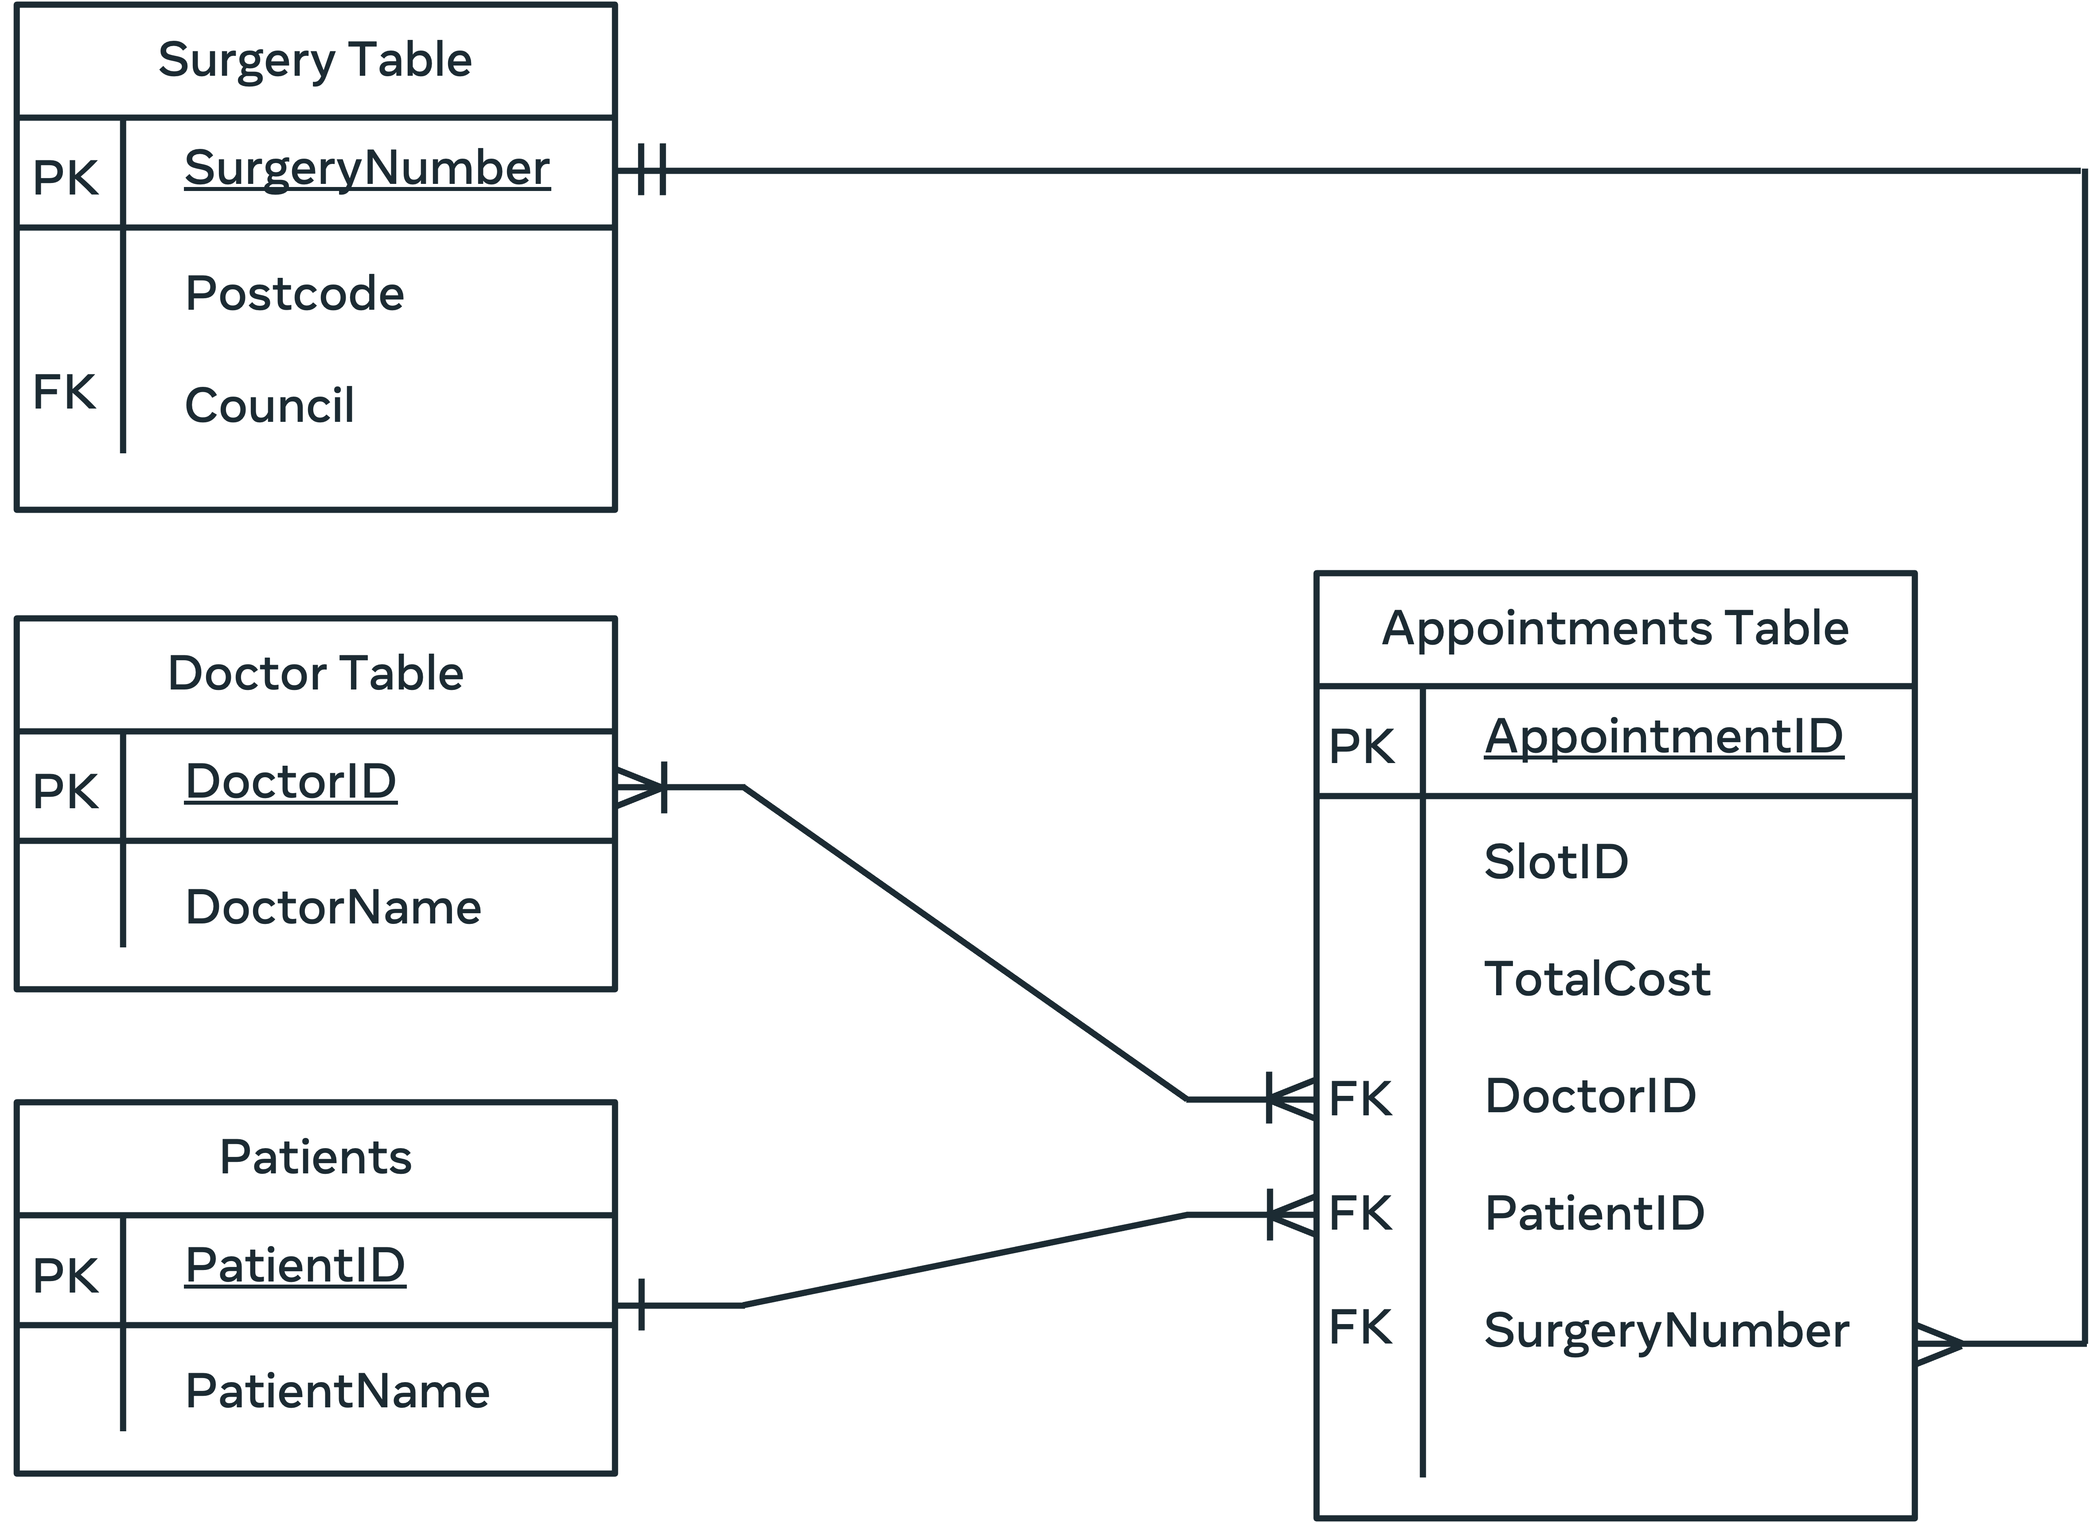

## **The hierarchical data model**

The hierarchical data model is organized in a tree-like or a parent-child structure, where each record of data has one parent node and can also have several child nodes.

With this model, you can easily find data or add and delete information. However, this model only permits one-to-many relationships between nodes, as each child node can have only one parent node.

The following data model illustrates the database structure of an insurance company. In this diagram the insurance company is structured as follows:

* Department is a root node,
* The Agent and Staff nodes are linked to the parent Department root node.
* And the Computer and Employment nodes are linked to the parent Staff node.

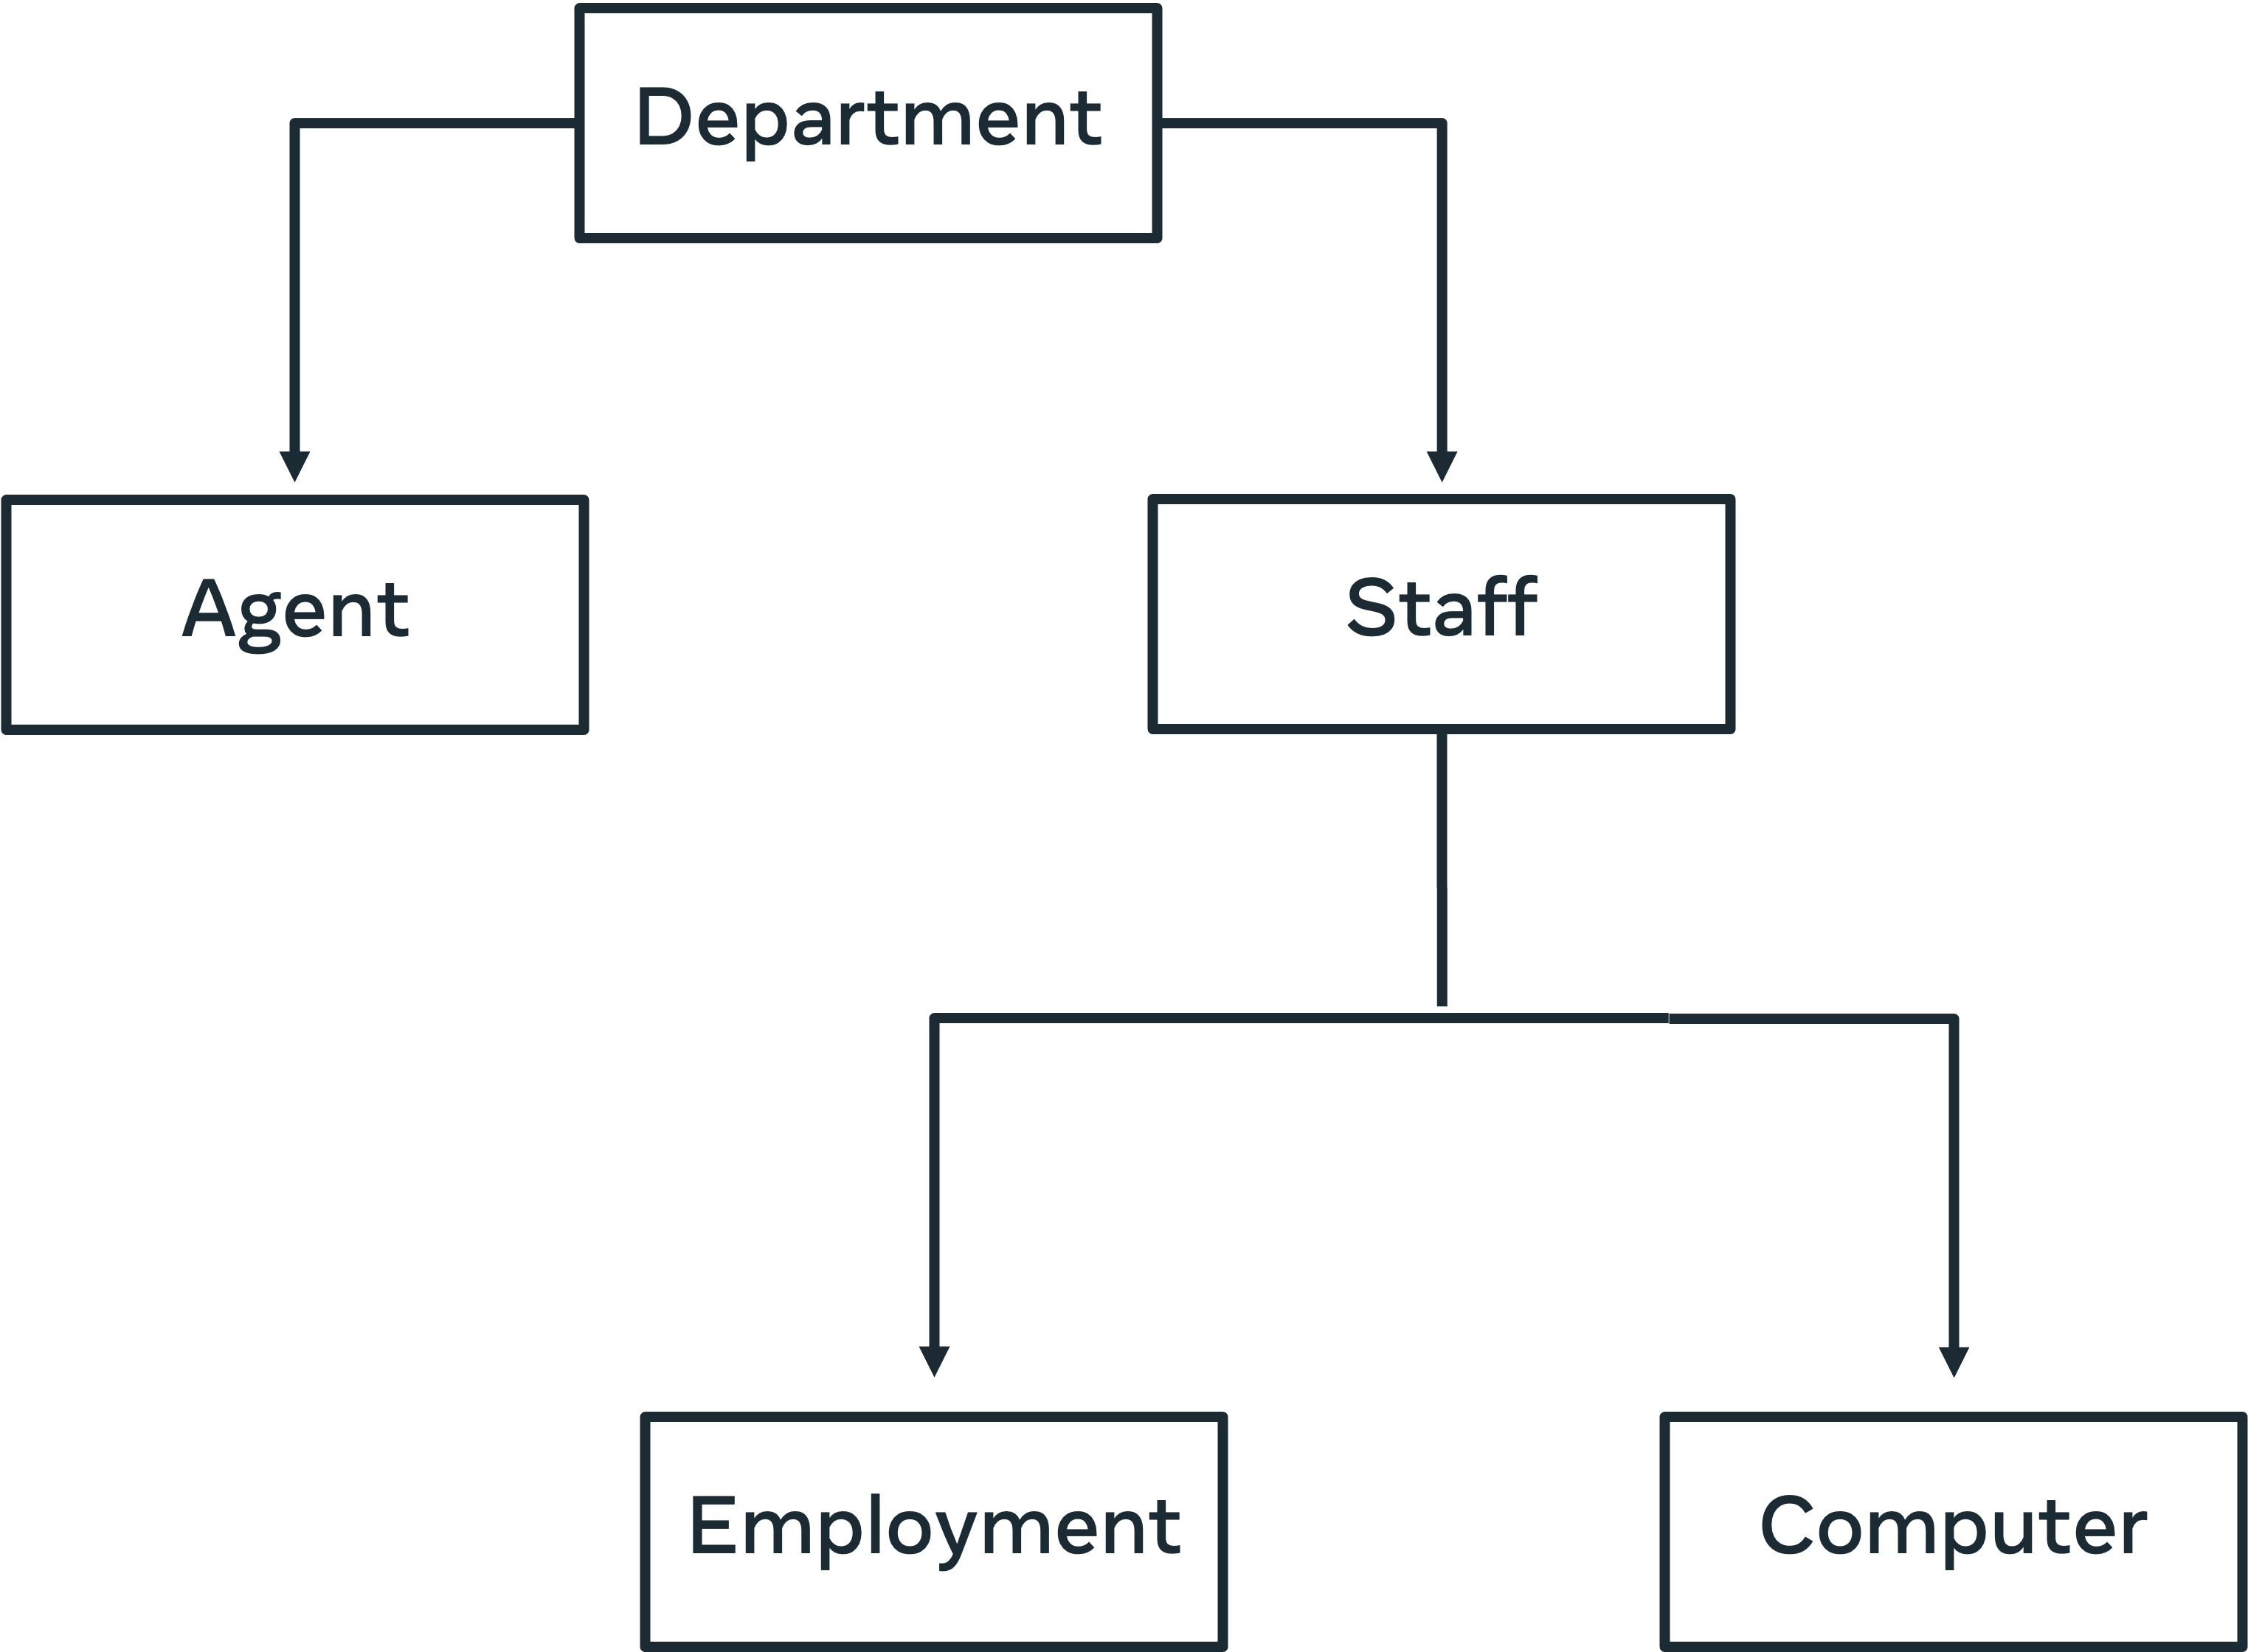

You may have noticed that a key advantage of this model is the simplicity of its structure. Also, since each record has only one parent, you can navigate through the database quickly and efficiently. However, you should be aware that, in this model, if you delete a parent node then the corresponding child records are also deleted.

In addition, this model does not support many-to-many relationships, which may be required in some cases (such as in the previous surgery scenario).

It’s also difficult to re-organize the structure of a database to incorporate new requirements. Doing so may disrupt the existing parent-child relationships.

You can use ER diagram to represent a more detailed level of this model as shown below.



The Object-Oriented data model

The Object-Oriented data model is based on the Object-Oriented concept, where each object is translated into a class that defines the respective object’s characteristics and behavior.

In this model you can use different types of associations between objects such as aggregations compositions and inheritance. These features make object-oriented databases suitable for complicated projects. However, making use of this model requires a good understanding of object-oriented programming.

In the following course enrollment diagram, there are six classes:

* Person,
* Student,
* Professor,
* Course,
* Address
* and Enrolment.

Each class consists of a set of attributes and methods.

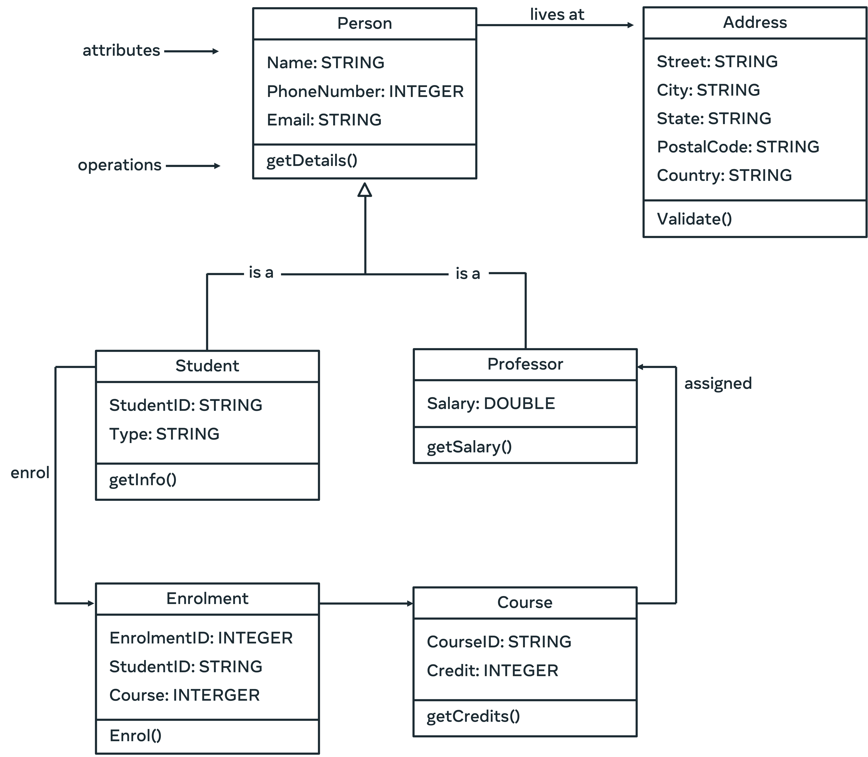

In this example, each class represents similar objects in the database. This means that similar objects have the same characteristics and behavior. For example, each student registered in the database system has same set of attributes (or instance variables) such as id and type. Also, each object instance of a class utilizes the same operations stated in the class.

In addition, there are different types of associations defined in the diagram as follows:

* Each student and professor are a person (inheritance relationship) and each person is associated with an address.
* Each enrolment involves a student and a course. The enrolment class in this case is called association class.
* Each professor is assigned a course.

## **Conclusion**

This reading provided you with an overview of how to model databases using different types of data models through the use of relevant real-life examples.

**Normalization** is an important process used in database systems. It involves structuring tables in order to reduce data duplication, avoid data modification implications, and simplify data queries from the database.

**Insertion anomaly →** New data requires the insertion of additional data

**Update anomaly →** An update of a record results in further updates.

**Deletion anomaly →** A deletion of a record deletes more than one data set.

**Data atomicity**

Atomicity means that multiple operations can be grouped into a single logical entity, that is, other threads of control accessing the database will either see all of the changes or none of the changes.

An example of an atomic transaction is a monetary transfer from bank account A to account B.

**First normal form**

Enforces data atomicity and eliminates unnecessary repeating data groups.

**Second normal form**

A table cannot contain any relationships built on functional or partial dependency.

The table must be defined with a composite primary key.

**Third normal form**

Resolve issues of transitive dependency, when non-key attribute depend on one another.

# Additional resources

The following resources offer additional reading materials on the topic of database modeling.

* [IBM guide to data modeling](https://www.ibm.com/cloud/learn/data-modeling)
* [Microsoft guide to the basics of database normalization](https://learn.microsoft.com/en-us/office/troubleshoot/access/database-normalization-description)
* [SAP guide to data modeling](https://www.sap.com/insights/what-is-data-modeling.html)

**Database modeling in MySQL Workbench**

A unified visual tool for database modeling and management

MySQL Workbench's forward engineer feature can be used to create a data model in MySQL Workbench, and then transform it into a SQL schema that can be implemented automatically in MySQL.

MySQL Workbench for data modeling and data management

This reading outlines the role of MySQL Workbench in database modeling and data management. It provides an overview of the main database tasks that can be performed in MySQL Workbench.

## **Overview**

MySQL Workbench (WB) is a unified visual tool for database modeling and database management. The WB was developed by Oracle, the company that manage MySQL. MySQL Workbench is a free, open-source and cross-platform tool that runs on Windows, Mac and Linux.

MySQL Workbench enables you to speed up the database design process by using the visual SQL editor. It also allows you to migrate data from different kinds of relational database systems.

## **Visual Database Design**

MySQL Workbench simplifies database design and maintenance. It enables database engineers to document the requirements in the form of visualized ER diagrams. This lets you communicate your design ideas with stakeholders in a professional way.

MySQL WB designer tool facilitates model-driven database development, which automates the development process without the need to code each part of the database system.

In addition, by using MySQL WB database engineers must design data models that meet the expected standards, otherwise they can’t implement these data models directly in MySQL.

In other words, MySQL WB allows you to develop a complete entity-relationship diagram with auto Layout and arrangement of data models.

## **Forward and Reverse Engineer Methods**

MySQL Workbench provides capabilities for creating data models in the visual designer. You can then use the Forward Engineer method to create a relevant data model in your MySQL server. The SQL schema is automatically generated for you. You can amend the code if required, or you can execute it with just a few mouse clicks.

MySQL Workbench also offers the Reverse Engineer method. You can use this method to create or import a MySQL database file and then generate a relevant data model from the SQL script. You can modify the model if needed, and then utilize the forward engineer method to create a new database system in MySQL.

## **Database Management**

Database management typically involves maintaining different versions of your database schemas. To help you with database management, MySQL WB can be used to perform Schema Synchronization and Comparison functionality. These features provide you with the ability to compare either two databases or a database and a data model, so you can visually detect the differences. MySQL WB also allows you to synchronize the data model with a live database and vice versa.

## **Database Documentation**

As a database engineer, you need to document the design of your database. This can be very time consuming. MySQL Workbench provides a documentation tool called DBDoc to document all details of your database design. You can use this tool to generate the documentation of your models in either HTML or plain text format.

## **The Visual SQL Editor**

MySQL WB visual SQL editor is used to write, run and debug SQL statements. It also facilitates SQL code completion and provides a context-sensitive list of SQL keywords and objects.

In addition, it includes a SQL code formatter that automatically formats SQL code to make it easier to read and edit. Other useful features include:

* SQL syntax highlighting,
* SQL code generation,
* The ability to reuse  your favorite SQL snippets,
* A running history of all executed SQL queries,
* And the ability to quickly create tables, indexes, views, stored procedures, triggers and functions.

## **Visual Database Administration**

With MySQL WB you have complete administrative control over all aspects of your MySQL server, including:

* User accounts,
* Roles,
* Privileges,
* Server start/stop,
* Logs,
* And server configuration.

## **Data Management**

MySQL WB provides useful features for managing data in MySQL database including the ability import and export mysqldump files, and export query results sets as CSV, XML, HTML files.

The WB Visual Data Editor also allows you to view and edit result sets in a grid table.

You can also view multiple result sets in the same visual data window. And you can perform data search and pattern matching searches across all tables and schema.

## **Database Migration**

In MySQL WB, you can use the Database Migration Wizard to perform data migration between different versions of MySQL servers.

In addition, you can also perform data migration with different relational database management systems such as Microsoft SQL Server, Sybase ASE, Sybase SQL Anywhere, PostgreSQL, and SQLite.

## **Conclusion**

MySQL Workbench has many useful tools that allow database developers to virtually create database models that can be easily transformed into physical MySQL databases.

Also, the WB allows MySQL administrators to configure and secure their database systems and assign users different types of roles and privileges.

In addition, it enables designers to use the visual editor to create database schemas, tables, views, stored procedures, functions and triggers.

# Additional resources

The following resources offer additional reading materials on the topic of data modeling and data management in MySQL Workbench:

* [Overview of process steps for installing MySQL Workbench](https://dev.mysql.com/doc/workbench/en/wb-installing.html)
* [Oracle guide to downloading and installing MySQL Workbench on MacOS](https://dev.mysql.com/doc/refman/8.0/en/macos-installation.html)
* [Oracle guide to getting started with MySQL Workbench](https://docs.oracle.com/cd/E19078-01/mysql/mysql-workbench/wb-getting-started-tutorial.html)
* [MySQL.com guide to visual database design in MySQL Workbench](https://www.mysql.com/products/workbench/design/)
* [Oracle guide to creating a data model](https://docs.oracle.com/cd/E19078-01/mysql/mysql-workbench/wb-getting-started-tutorial.html)

**------------------------->>>>>>>>>>WEEK2 <<<<<<<<←-----------------------------**

**Data warehouse**

Centralized data repository that aggregates, stores and processes large amount of data from multiple sources. It separates the data analysis workload from the standard transaction workload of a regular database management system. Users can then query this data to perform data analysis. This type of database is called online analytical processing or OLAP. A regular database focuses on collecting, storing, and processing data in real-time. It's also known as online transactional processing or OLTP.

**There are four key characteristics of a data warehouse.**

* **Subject-Oriented** → a data warehouse which explores one or more subject or topic areas.

When building a data warehouse, you need to choose one or more subject areas to explore. For example, global superstore can build a data warehouse that focuses on sales. They can then use the warehouse to find all relevant information on their sales processes.

* **Integrated** → a data warehouse which integrates data from a range of different sources.

This data must be integrated in a consistent format. Integrated data must also resolve issues such as naming conflicts and data types. Global superstores data warehouse integrates data from online purchases, website interactions, and social media.

* **Non-volatile** → a data warehouse must maintain data as it was loaded.

Non-volatile means data should not be deleted once it's loaded to the data warehouse. The purpose of a data warehouse is to analyze data as it exists. The more data you have, the better the results of your analysis.

* **Time variant** → Data warehouse must aggregate data over a long period of time for accuracy.

A data warehouse aggregates data over a long period so that it can measure changes in data over time. This helps users to discover trends, patterns, and relationships between data elements. For example, global superstore can use data from the last few years of sales to find out why their profits have declined.

* **Structured data** → data that’s structured within a well-defined data model.

They are structured data, semi-structured data, and unstructured data. Let's start with a look at structured data. This is data that's presented in a structured format within a well-defined data model. The relational database model is commonly used for structured data. The organized tables help users to access manage and search for data using sequel. A data warehouse typically uses structured data. This data type is organized for a specific purpose so it's easier to gain insights from and uncover answers to specific questions.

* **Semi-structured data →** partially structured data which requires more effort when performing data analysis. An example of semi structured data is an email message. It can contain structured data like a sender and subject, but the body is unstructured and can contain several different kinds of data like text, images, and videos.
* **Unstructured data →** data that doesn’t adhere to any specific pre-defined data model.

It can include any kind of data like text, video, or audio. This data can be collected and stored without applying any form of data model. But analyzing unstructured data requires advanced data analytics mechanisms like machine learning and data mining.

Semi-structured and unstructured data are more suited to a data lake. This is like a data warehouse but it can handle unstructured data. Data lake is used more widely by data scientists. Businesses prefer working with structured data and data warehouses because of its accuracy.

**Global super store’s data warehouse architecture**

Global super store have built a data warehouse architecture that you can explore.

**Data warehouse architecture**

The design of the data warehouse various components.

Data source

Data warehouse

Presentation

Data staging

Let's explore these components and find out more about how they contribute to the data analysis process. The first component of a data warehouses architecture, is the sources of data that it relies on for its insights. These include external sources like Global Super Stores, online surveys or social media data. Internal sources like information collected within the company database on customers and products. Operational data produced by day to day business activities like customer orders, and data sources can also include flat files. These are files without an internal structure like customers, online behavior or data log entries. Make sure that the data sources are accurate, so that you can avoid irrelevant or poor data analytics.

The next component is data staging, the data staging area includes a set of processes known as the ETL or extract, transform and load pipeline.

Data is stored in the data storage component. This is a central database repository that serves as the foundation of the data warehouse, it organizes data in relational databases. It also includes a metadata repository that holds different kinds of information about the data. Like, where it was sourced from the features of the data and the tables the data is stored in along with their attributes. What does metadata mean in the context of a data warehouse. Metadata is essentially a table of contents for the data in the data warehouse. It helps database engineers manage and keep track of the changes within their source systems, methods and processes. For example, Global Super Stores metadata contains information like where the data was sourced from. It also shows, when each file was created, who created it and other important information

The next component in the data warehouse is data marts, these are subject oriented databases that meet the demands of a specific group of users. Each mark contains a subset of data that focuses on particular parts of the business or organization. For example, Global Super Stores data marts relate to specific departments and business functions. They can use these mass to perform focused analytical processes on specific parts of the business.

Finally, once the data is ready, you can perform data analytics. Data analytics is performed using different analytics techniques like data mining. Once you've analyzed the data, you can then present it. The data can be presented in the form of reports like interactive reports, analytics, reports or static reports. Global Super Stores data analysts, can analyze the data within their repository using different techniques. They can then produce reports that provide information on sales, profits and other important aspects of the business.

**Data warehouse architecture best practices**

* Separate analytical and transactional operations
* Use scalable solutions to process large amount of data
* Build a flexible architecture for future upgrades
* Implement data security features
* Develop a simple, flexible architecture
* Create an easy-to-use warehouse
* Document the development of the data warehouse

# The data warehouse Extract, Transform and Load (ETL) process

This reading provides more details about the data warehouse ETL processes. It provides an overview of the process, an in-depth exploration of each process step, and a list of useful tools that you can use when working with a data warehouse.

## **Overview**

ETL is an acronym for “Extract, Transform, and Load”. It is an essential part of the data staging phase in the data warehouse architecture. ETL describes the set of processes that extract data from different source systems, transform the data into a suitable format, and load it into a data warehouse repository for data analytics.

Typically, data warehousing includes complex ETL processes and requires active involvement from stakeholders including data engineers, data analysts, business analysts, testers and managers.

As a database engineer, you should carefully evaluate any changes that impact the business in your design of ETL processes in a data warehouse. You must ensure a complete separation between the analytical operations and the day-to-day transactional operations. You also need a scalable solution that can process  huge amounts of data.

## **How does ETL work?**

The ETL three step process represents the pipeline that moves data from its various sources and integrates it in a data warehouse. There are three steps in this process:

* Data extraction.
* Transformation.
* And Loading.

Let’s take a few minutes to explore each of these process steps in more detail.

## **Step 1: Data Extraction**

This step in the process involves extracting data from multiple sources into the staging area. For example,  Global Super Store may use different database management systems and files to maintain their data in the logistics, operations, sales and marketing departments. This could include MySQL, Oracle, PostgreSQL, Excel sheets and flat files as illustrated in the following diagram.

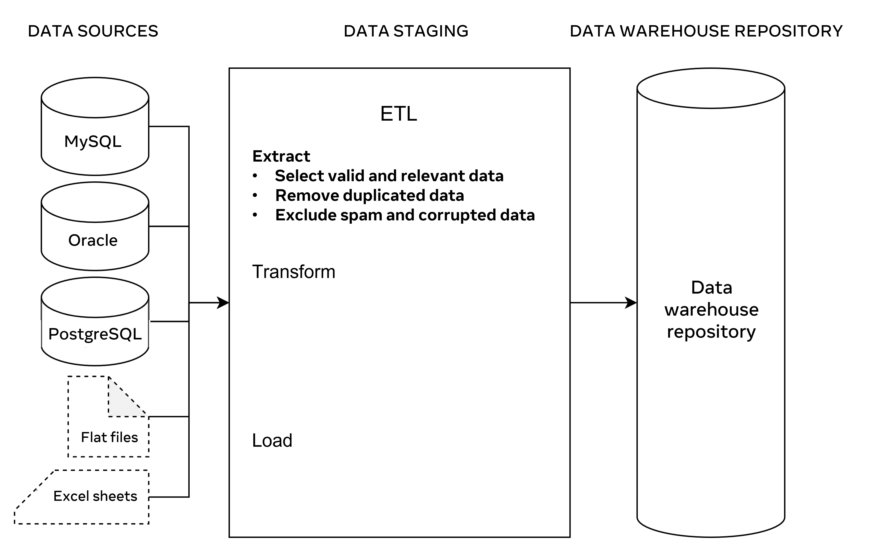

Global Super Store extract data from each of these sources in the staging area. When you design this process, it is important that you:

* Extract relevant data only to avoid data overloading.
* Include valid data and remove all duplications to obtain more accurate results.
* Exclude spam and corrupted data, as this will save a lot of effort during data cleaning and preparation.
* Validate data against the initial data in the sources to ensure it can be used in the same way in the data warehouse

## **Step 2: Transformation**

This process requires converting data from one format into another, or from one structure into another according to the predefined data model established in the data warehouse. This is a crucial step to integrate data in the data warehouse repository.

Data already built-in to the relational database may not necessarily require a transformation. It may be imported directly as is to the data warehouse repository. However, you may need to clean and prepare the data before you use it for data analytics.

For example, if a customer’s first name and last name values are stored separately in two different columns then they can be concatenated in a ‘full name’ field before they are loaded into the data warehouse repository. Or if data includes buying and selling costs, then you can create new calculated field for data profit.

Data transformation becomes more crucial when you work with raw data (like the atomic type of data that a computer cannot make useful information of it on its own). Good examples of raw data include computer logs, user navigation cookies and search histories. These types of data can be found in flat files, or in comma separated values (CSV) files.

In a data warehouse you should include structured data for data analytics. To do this, you should organize transformed data in tables, define data with specific datatypes, and set constraints in tables and columns. This creates records of related data that can be accessed, queried and analyzed to present useful information.

The main tasks in the transformation process include formatting, cleaning, preparing, organizing and integrating data, as illustrated in the following diagram.

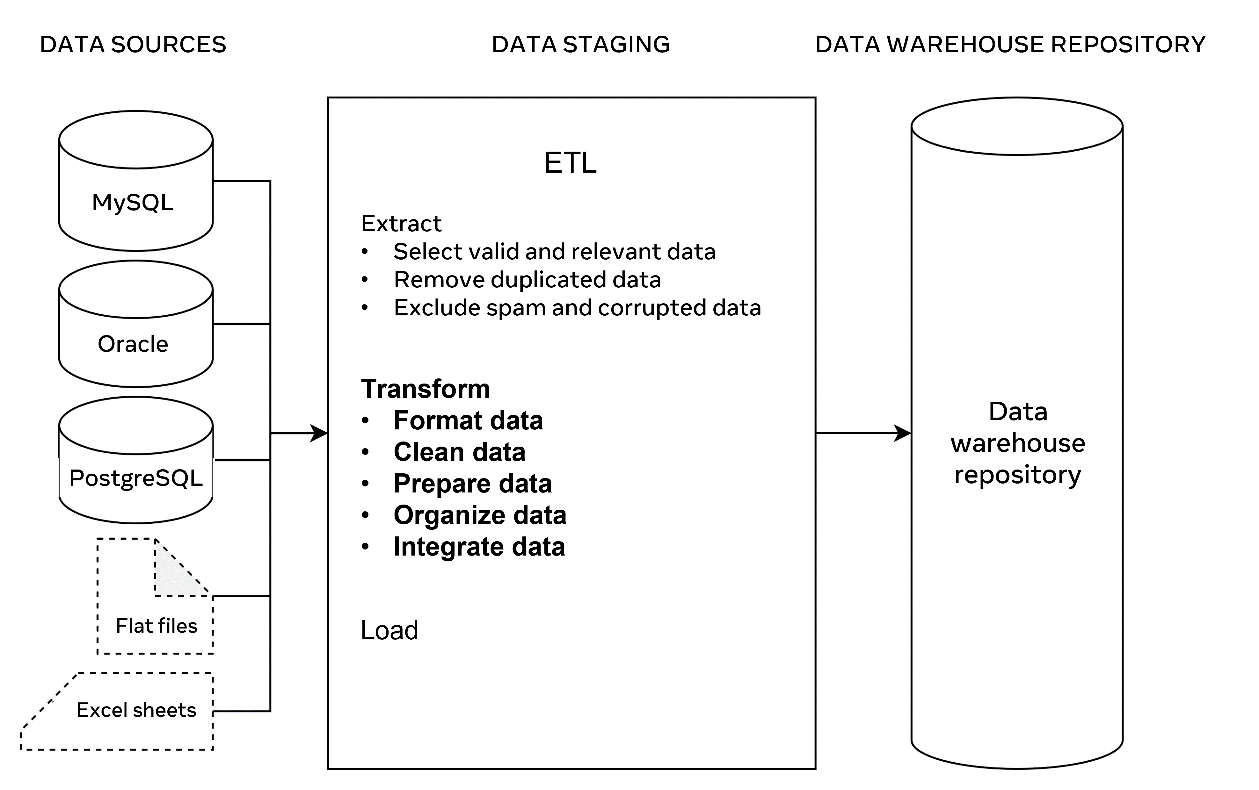

It is also important to ensure data integrity and consistency in the Transform phase. For example, a customer’s name may be spelled in different ways in different data sources such as John or Jon. Or a phone number could be recorded in different ways (For example, with and without country code). Dates and times could also be collected in different formats.

## **Step 3: Loading**

This process is the last step in ETL. In this step, large amounts of data are loaded into the data warehouse repository.  So, it’s important to deploy some recovery mechanisms in case of data loading failure. This means that you can resume the loading process from the point of failure without data loss and while also maintaining data integrity.

In this context, you can perform three types of data loading:

* Initial load: Populates extracted data to the data warehouse repository.
* Incremental load: Loads new data from the data sources to the current repository.
* Full refresh load: Erases the contents of the database in the data warehouse repository either partially or totally and re-populates it with fresh new data.

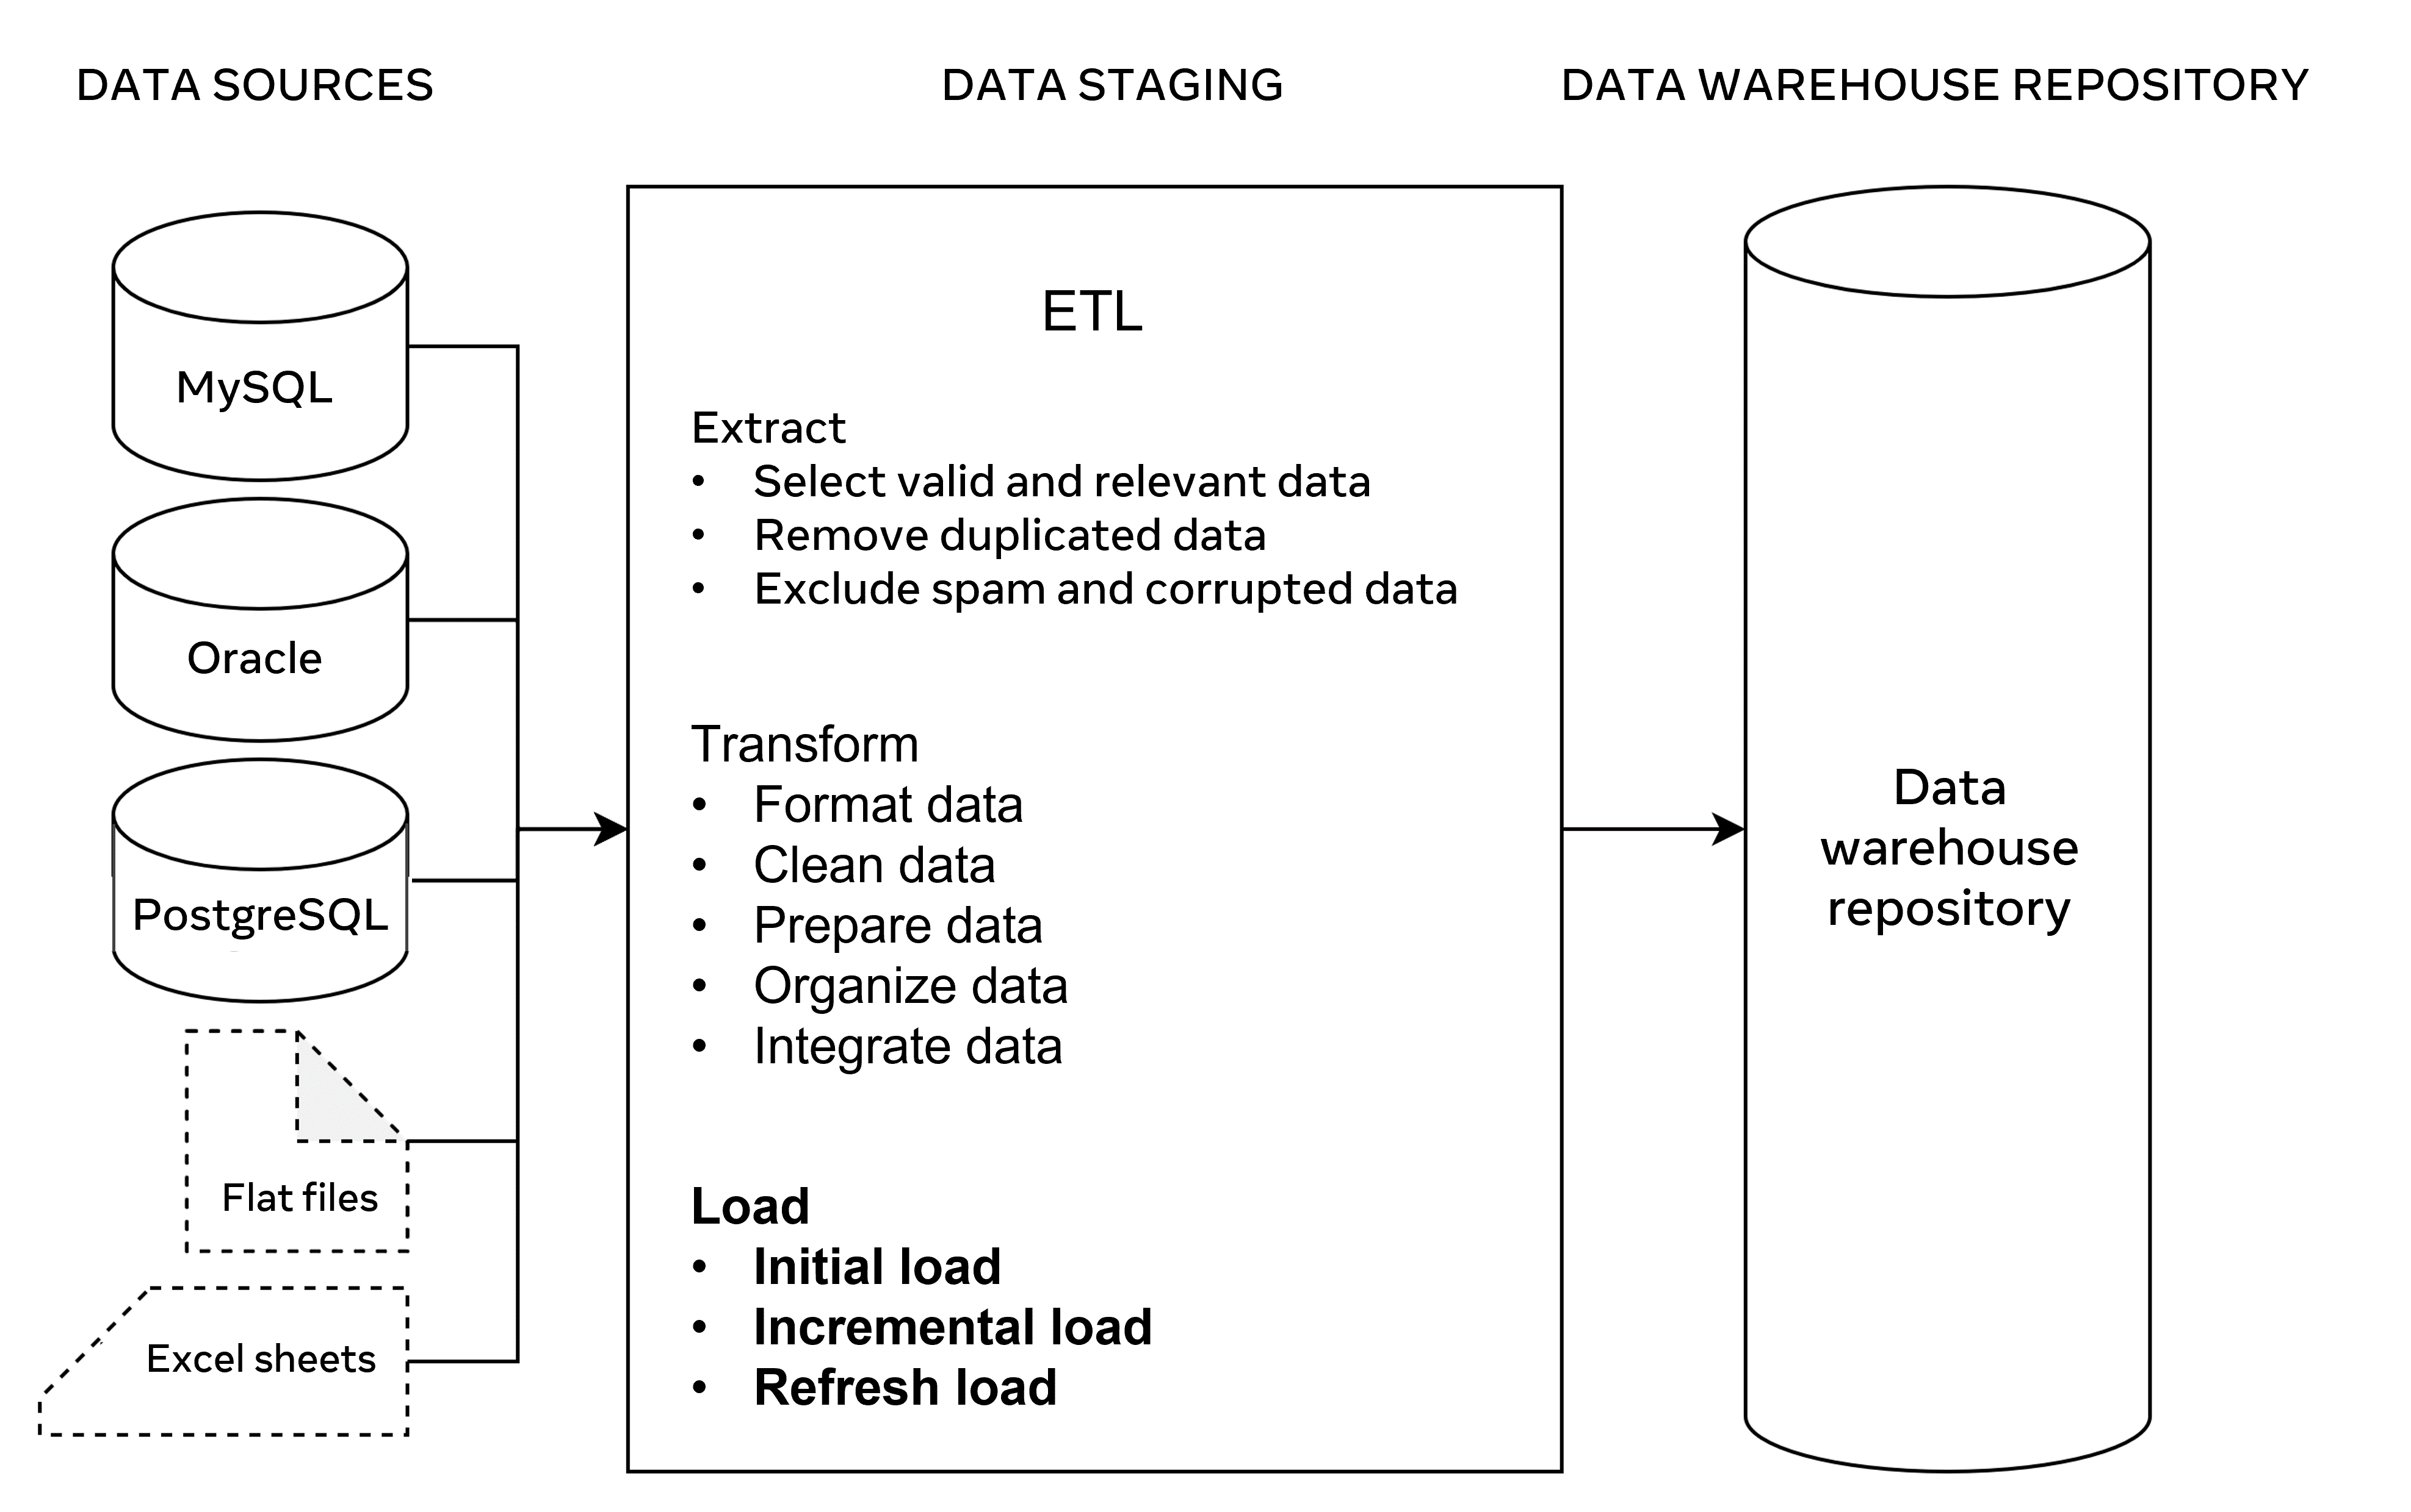

## **ETL Tools**

There are several tools available that you can use to carry out these ETL processes. These tools automate the extract, transform and load processes into an advanced level. Some examples of these tools include:

* Oracle: The industry-leading database that offers a wide range of choices of different data warehouse solutions.
* Amazon RedShift: A simple and cost-effective data warehousing tool that can be used to analyze all types of data.
* MarkLogic: A data warehousing solution that makes data integration easier and faster than other tools. It can query different types of data like search engine data, flat files and RDF.

## **Conclusion**

ETL provides a systematic approach for moving data from various data sources into a data warehouse. The data warehouse provides a central data repository that supports different types of data analytics and reporting. Therefore, a well-designed and documented ETL process is essential for developing an optimized and useful data warehouse.

# ETL testing

This reading provides an overview of ETL testing and best practices that should be followed during the testing process.

## **Overview**

A data warehouse provides a central data repository that supports advanced data analytics and reporting. ETL refers to the Extract, Transform, and Load processes required to move data from various data sources into a data warehouse.

To complete the ETL processes you need to:

* Extract relevant and valid data.
* Transform the extracted data into a suitable format and structure.
* And load the transformed data from various data sources into the data warehouse repository.

But how can you ensure that the loaded data is correct, valid, reliable, and consistent?

## **ETL testing**

The main purpose of ETL testing is to ensure accuracy, reliability, validity and consistency of loaded data. ETL testing investigates whether there are problems in ETL processes that prevent the creation of good quality data. This can be applied by carrying out the following actions:

* Mapping data in an appropriate way.
* Validating data.
* Checking duplicates of data.
* Validating dates.
* And verifying the completeness and correctness of data.

## **ETL testing in practice**

Global Super Store has many different departments, each of which manages customer data in a different way on different servers using different unique identifiers. For example, the sales department uses customer phone numbers as unique IDs, while the marketing department uses automatically generated customer IDs.

Also, certain data is represented in different ways. For example, customer full names are stated as one field in the sales department. But they’re stated in two fields in the marketing department (as first name and last name). The date in sales department is formatted as yyyy-m-d (for example 2020-9-5). Yet it's formatted as yy\m\d (or 20\9\5) in the marketing department.

This raises several problems for Global Super Store. A key issue that it can’t investigate which customers placed orders after their recent marketing campaign, because customer IDs are stored in different formats across the different departments. The solution to this problem is to create a new database model in the data warehouse. They can then extract relevant data, transform it and load it from the sales and marketing databases.

The new model could include:

* The Orders table with order ID, and order date.
* The Marketing table with marketing ID and marketing date.
* And the customer table with each customer’s full name, initial unique identifiers from both departments and a new unique key that enables the identification of customers from both departments.

This new model makes it possible to link the purchase history of customers with the marketing campaign, and then perform relevant data analysis.

## **Performing ETL testing**

To ensure that the data has been loaded correctly, ETL testing should be performed using the following methods.

## **Data mapping document**

Create a data mapping document to transform data from both department’s data sources to the destination repository in the data warehouse. This document should be reviewed, verified and validated by database engineers and data analysts to ensure correct data mapping.

## **Data validation**

Perform data validation by comparing data structure, datatypes, data formats and constraints in the related source and target tables against the corresponding mapping document. You should also perform data validation to verifying date values when creating new records of data, as this allows the data warehouse system to extract new data from the data sources and update the relevant repository databases in case of changes in data.

## **Data completeness**

Ensure data completeness by verifying that all expected data is loaded into the target tables including records counts and rejected records. You also need to check for any constraints that have been applied and ensured that all unique values have been populated as required.

## **Data correctness**

Perform data correctness to resolve any data naming conflicts, check that all misspelled data has been corrected, and make sure that any unexpected data values (in other words, values that are out of range) have been fixed or removed.

## **Data quality**

Ensure good data quality by checking names and numbers of formats, precision, and null values where NOT NULL constraint is specified.

## **Unique data**

Run a duplicate check to ensure there are unique records of data available in all tables and that all duplicate records of data have been removed.

## **Conclusion**

ETL testing aims to verify whether data is loaded from a data source to the target database in the data warehouse as expected. This ensures proper data analytics by removing duplicated data and excluding spam and corrupted data. It also validates data against the initial data in the data sources, changes the existing data format into the right format and loads correct and consistent data into the data warehouse.

# Additional resources

The following resources offer additional reading materials on the topic of data warehousing:

* [Oracle overview of key data warehousing concepts](https://docs.oracle.com/cd/B10501_01/server.920/a96520/concept.htm)
* [Astera guide to data types](https://www.astera.com/type/blog/structured-semi-structured-and-unstructured-data/)
* [Oracle guide to ETL](https://www.oracle.com/integration/what-is-etl/)
* [Oracle overview of data lakes](https://www.oracle.com/big-data/what-is-data-lake/)

**Global Super Store’s data model**

Global Super Store need to design a data model that can handle data analytics

**Dimensional data model** → based on the concepts of dimensions and facts.

→ A model which targets specific aspects of an organization to resolve key issues.

**Dimensions** → data element that define a context for your measures.

Eg; time and location.

**Facts →** Quantifiable data within a database.

Eg; sales and profit.

**Stored measures →** aggregate measures that are stored in the data warehouse. This data is loaded from the data source and stored in the database warehouse repository.

Eg; sales data and products price.

**Calculated measures →** Data calculated using data from other measures.

Eg; global superstore can calculate their profit by deducting the sold products cost from the sold price. These measures are performed through queries that rely on calculation rules programmed in the data warehouse database.

**Best practices for designing a data model**

* Focus on specific business activities to examine
* Identify all useful dimensions
* Organize data in a way that’s easy to understand.

A common method for designing a dimensional data model is with the use of schemas. One of the most widely used schemas in a data warehouse is the **star** **schema**. The star schema is a common model for designing databases in a data warehouse. It's a simple dimensional data model that consist of facts and dimension tables organized as a star. One or more fact tables sit in the middle of the schema connected to one or more dimension tables. Global superstore can use a basic star schema to organize their dimensional data model.

Another schema that you can use to design your dimensional data model is the **snowflake** **schema**. It's called a snowflake schema because the schema diagram resembles a snowflake. When working with a snowflake schema, you should normalize your dimensions tables to eliminate data redundancy. The best approach to normalization is to group dimensions data into multiple simple sub-dimensions tables. The disadvantage of this schema is that it increases the number of dimensions tables and requires more foreign keys to connect the tables. More complex queries are required to join records when performing data analytics.

# **OLAP cubes**

## **Overview**

Data warehouses aggregate and integrate data from multiple data sources. This data is imported from Online Transactional Processing (OLTP) database systems, where data is structured to manage the day-to-day business operations in real time.

For example, Global Super Store sells products online to the entire world. So, it requires an OLTP database system to collect, update, retrieve and backup customers, products and orders data. This type of database is not very effective at performing data analytics.

To perform effective data analysis on OLTP databases, you need to restructure your data in Online Analytical Processing (OLAP) database systems that are created mainly for data analysis. Key advantages of OLAP database systems include the following:

* They facilitate multidimensional analysis.
* They provide tools for easy access and filtering of dimensional data.
* And they support fast retrieval of massive amounts of data.

These features enable data analysts to provide an optimized level of data analytics that help their audiences obtain answers to their questions about the performance of the business. Along this line, OLAP database systems utilize the cube structure to visualize the multidimensional data concept. OLAP cube is a multidimensional array used to store and maintain data to provide advanced level of data analysis with more interesting insights.

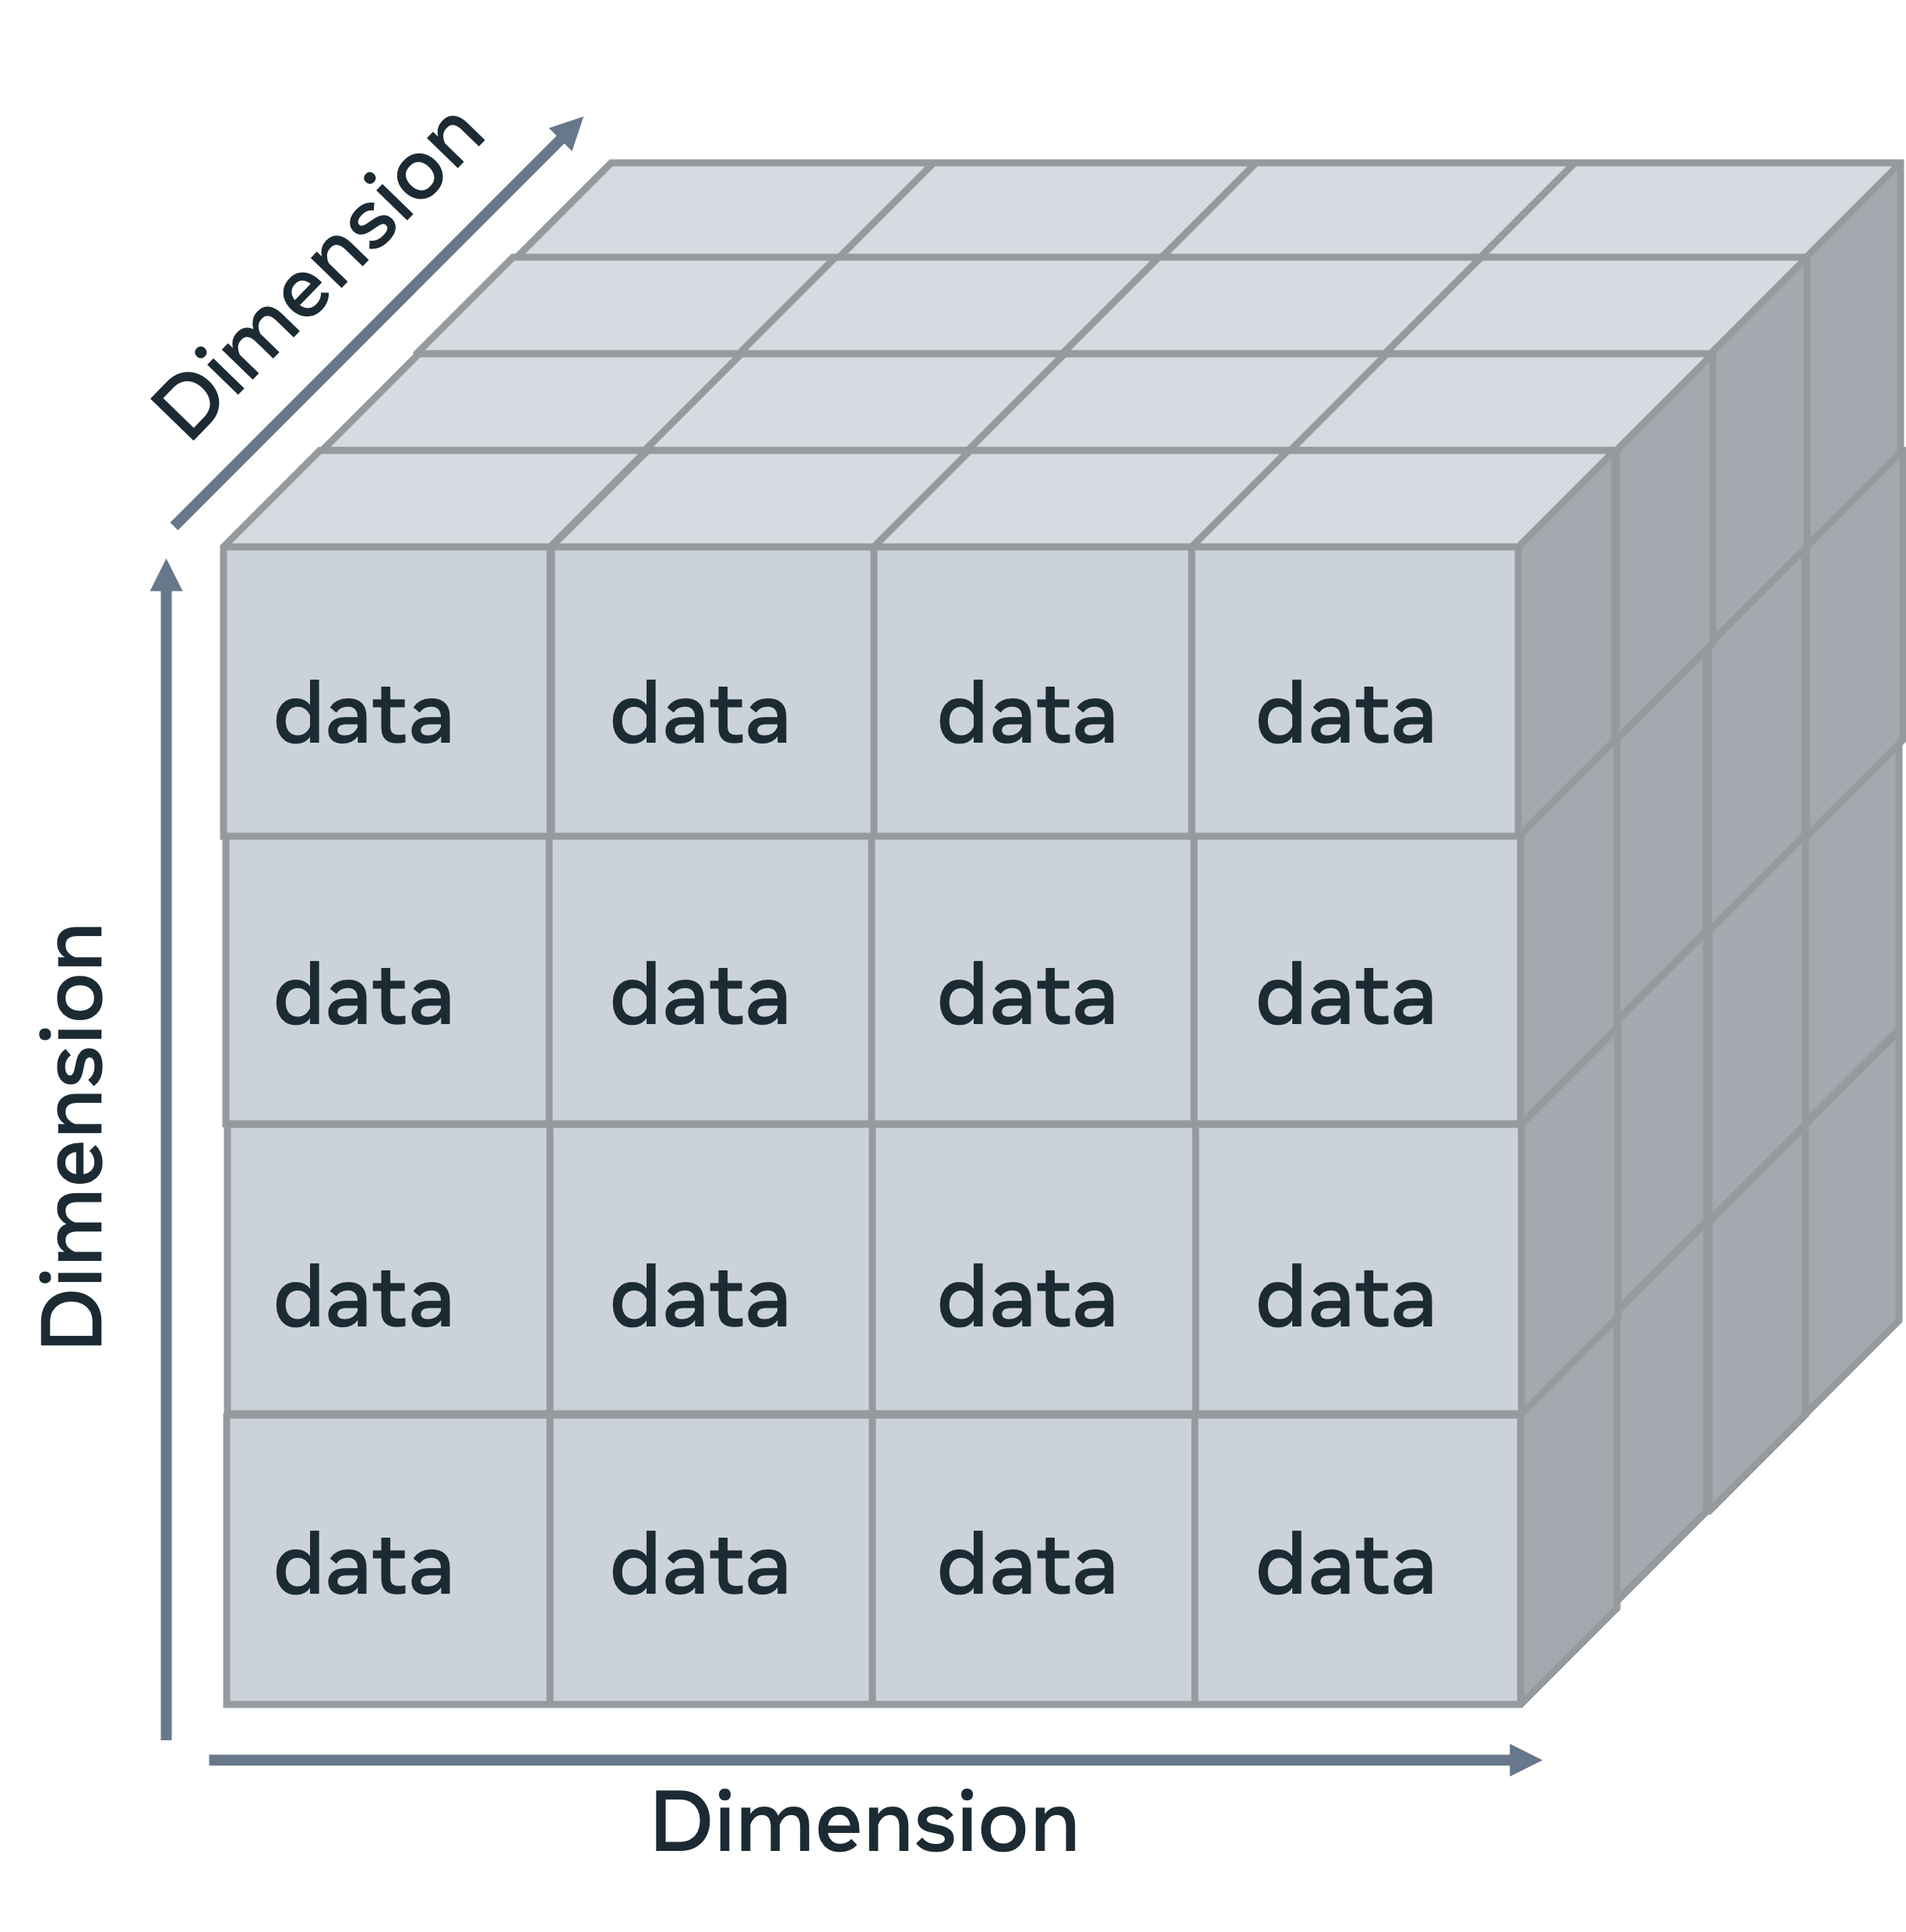

## **OLAP Cube in practice**

To perform data analysis, you need to be clear about which business activities you want to examine.  You also need to know which measures and dimensions are required to provide you with the most meaningful and useful information.

For example, Global Super Store sells furniture, office supplies and technology products around the world. They want to investigate the sales performance of different product categories over the last four years across four different European countries: France, Germany, Italy and the UK.

One solution is to analyze the company data in a basic way, where you provide Global Super Stores with three simple tables of data that show total sales made in each country, total sales made in each year, and total sales made in each category, as shown below.

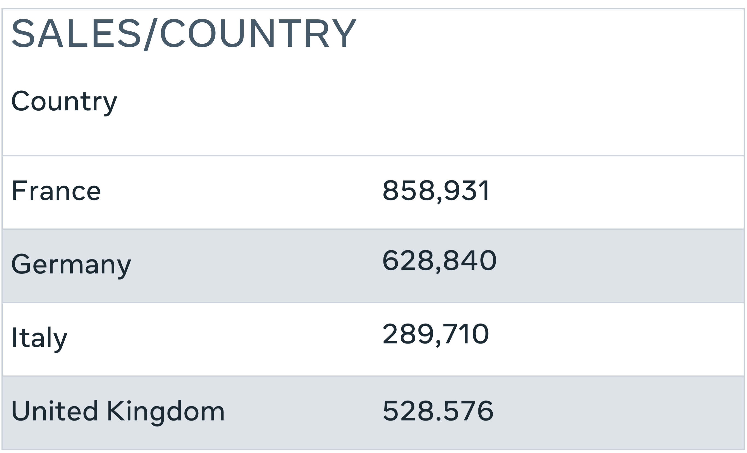

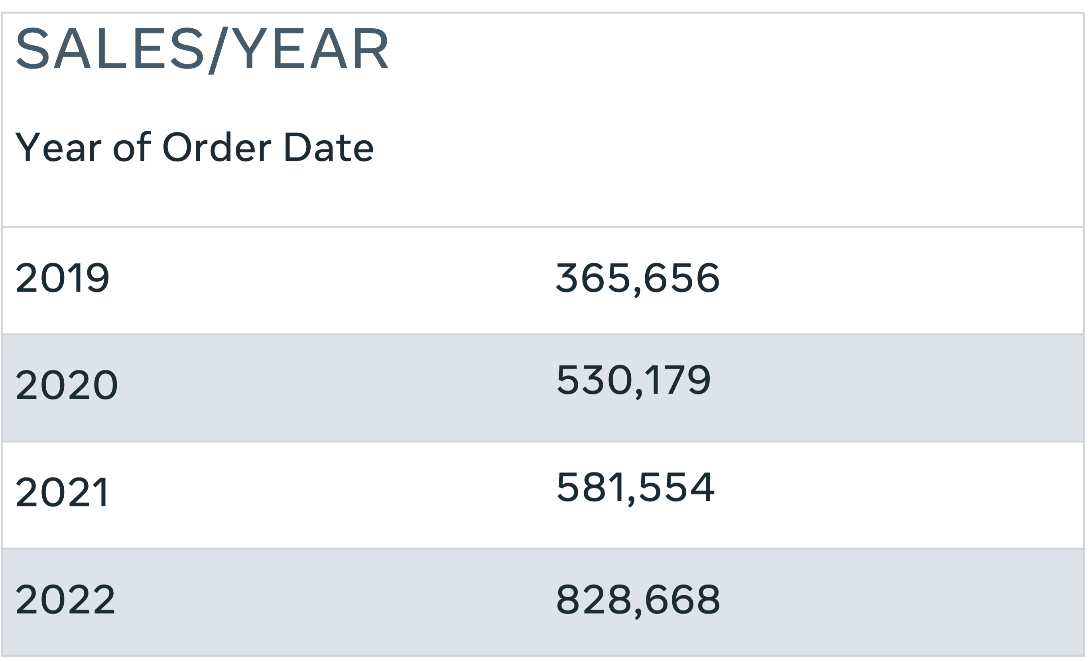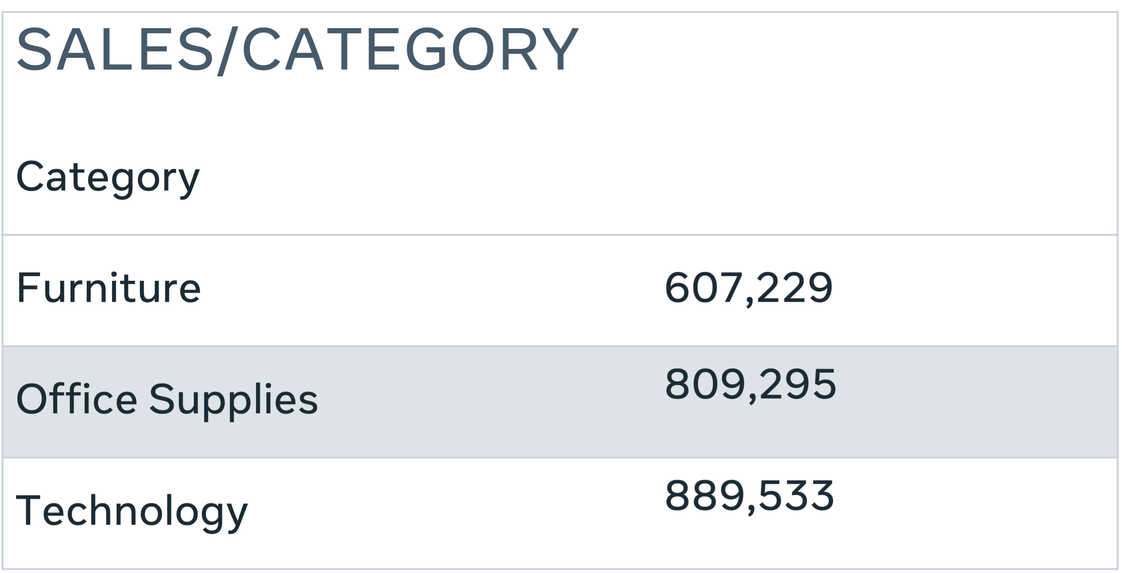

In each table of data, you are showing the total sales in the context of one dimension as follows:

1. Sales in the context of the Time dimension (Year – 2019, 2020, 2021 and 2022).
2. Sales in the context of the Location dimension (Country - United Kingdom, Italy, France and Germany).
3. Sales in the context of the Product dimension (Category - Furniture, Office Supplies and Technology).

However, this kind of analysis does not provide any deep insights into your data. And it is not that easy to investigate and compare data based on multiple dimensions, (which is required to facilitate more interesting information for the business decision makers). This is where multidimensional data analysis can play a major role with the OLAP cube.

In this situation, you can merge the three dimensions (Time, Location and Product) together in a multidimensional cube as shown below.

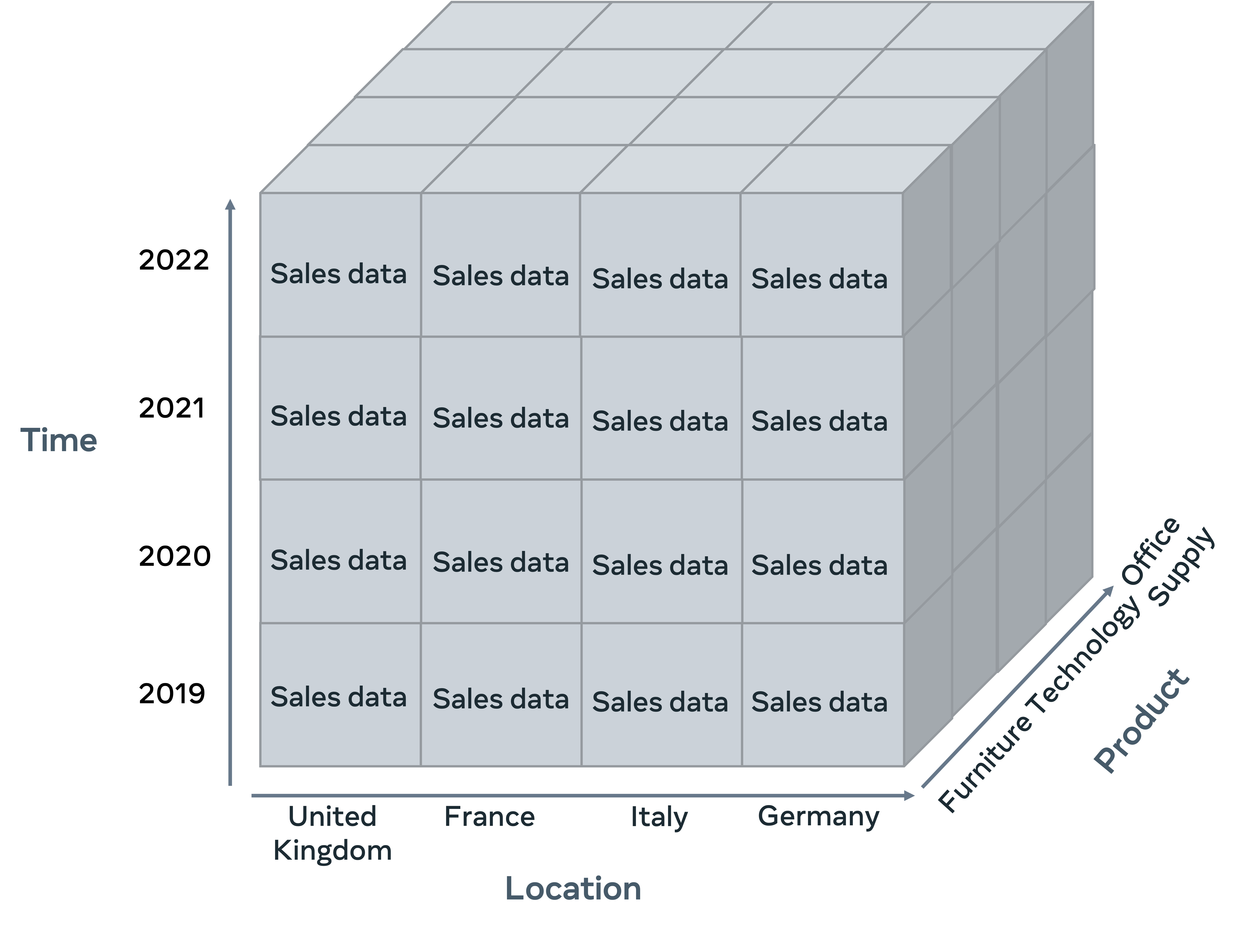You can now use the OLAP cube to analyze complex data more efficiently. You can then find answers for any questions you have about business sales operations based on different dimensions (like product, time and location) at the same time.

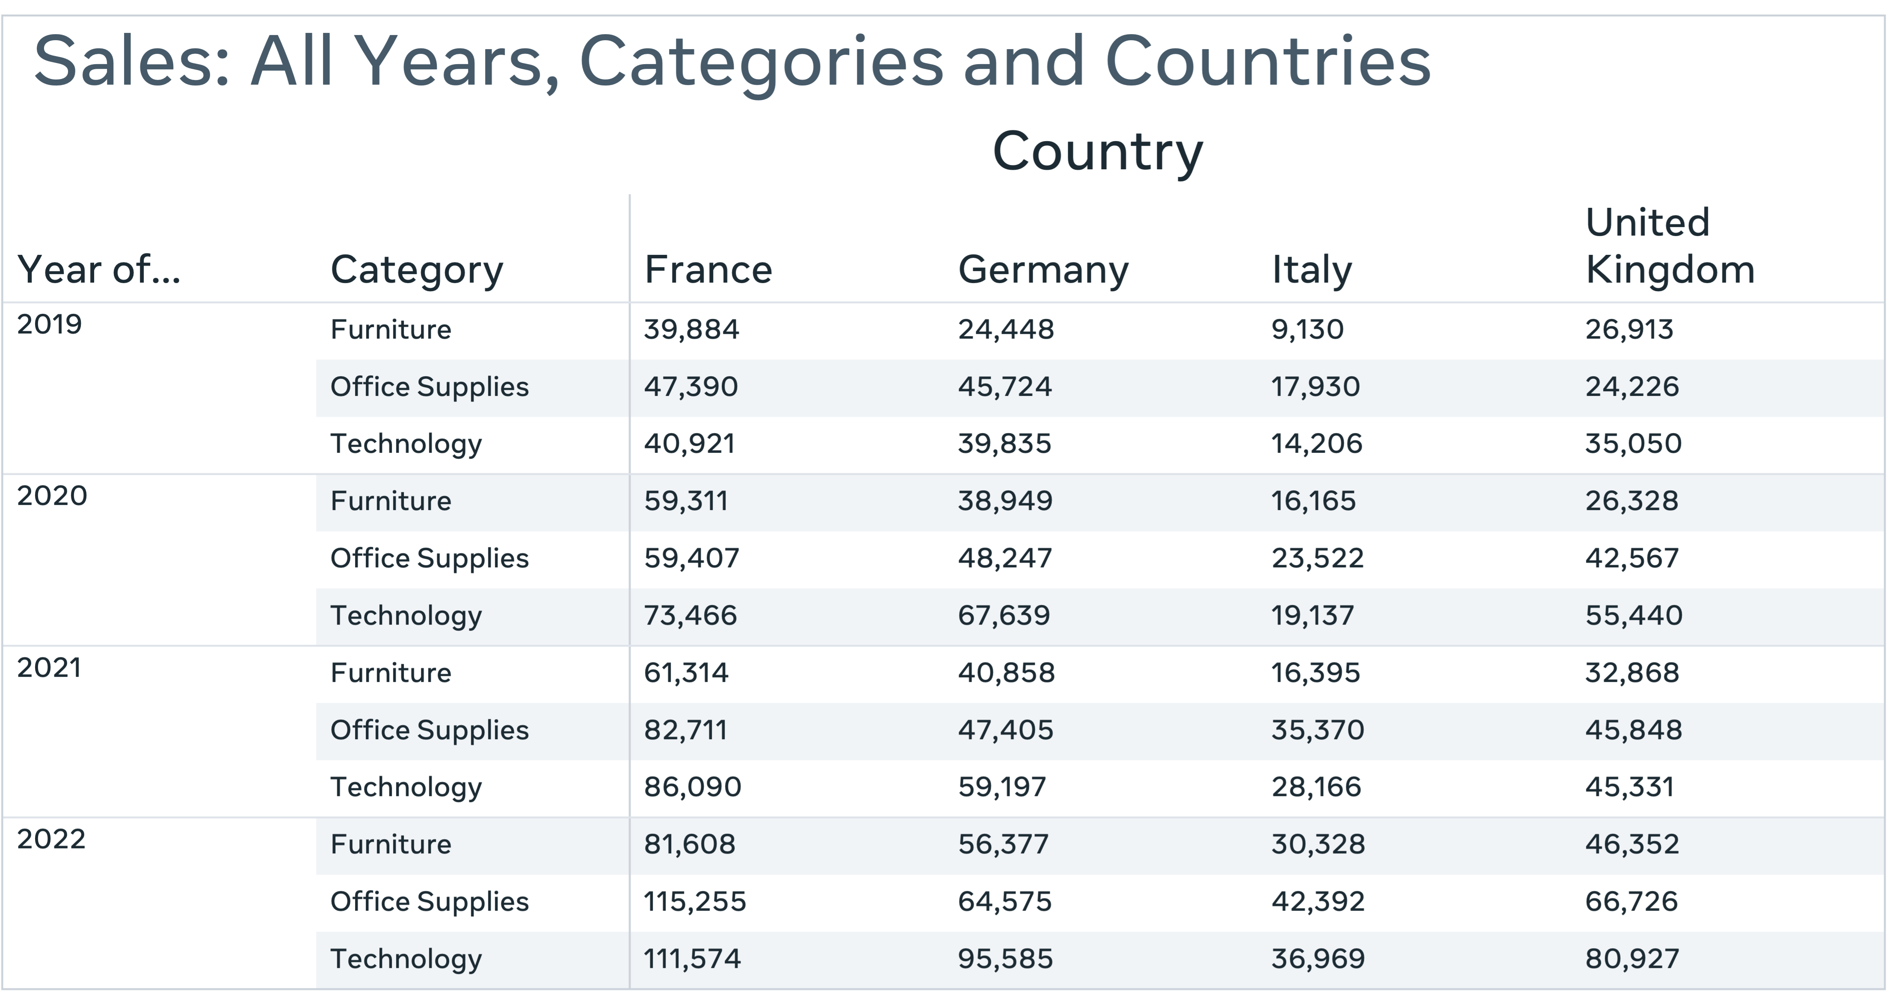For example, the following chart combines the three dimensions to demonstrate Global Super Store’s sales performance in terms of all categories of products, over the past four years, across the four specified countries:

In the above multidimensional chart, you are viewing the same data presented earlier. However, now you can easily compare data. You can now spot for example, that sales are strongest in France across all categories of products, whereas Italy has the lowest sales. You may have also noticed that there is an increase in sales every year.

As you can see, the multidimensional cube facilitates a more efficient method of providing a more meaningful view of information. This lets you interpret and compare data easier. In addition, you can use the OLAP cube to perform different types of useful operations such as Drill-down, Roll-up, Slice, Dice and Pivot. Let us have a look into some of these operations.

## **Slice**

A Slice operation focuses on a sub dimension from the cube, which provides a more focused view of information. In the following example, the cube focuses on the furniture category of the product dimension.

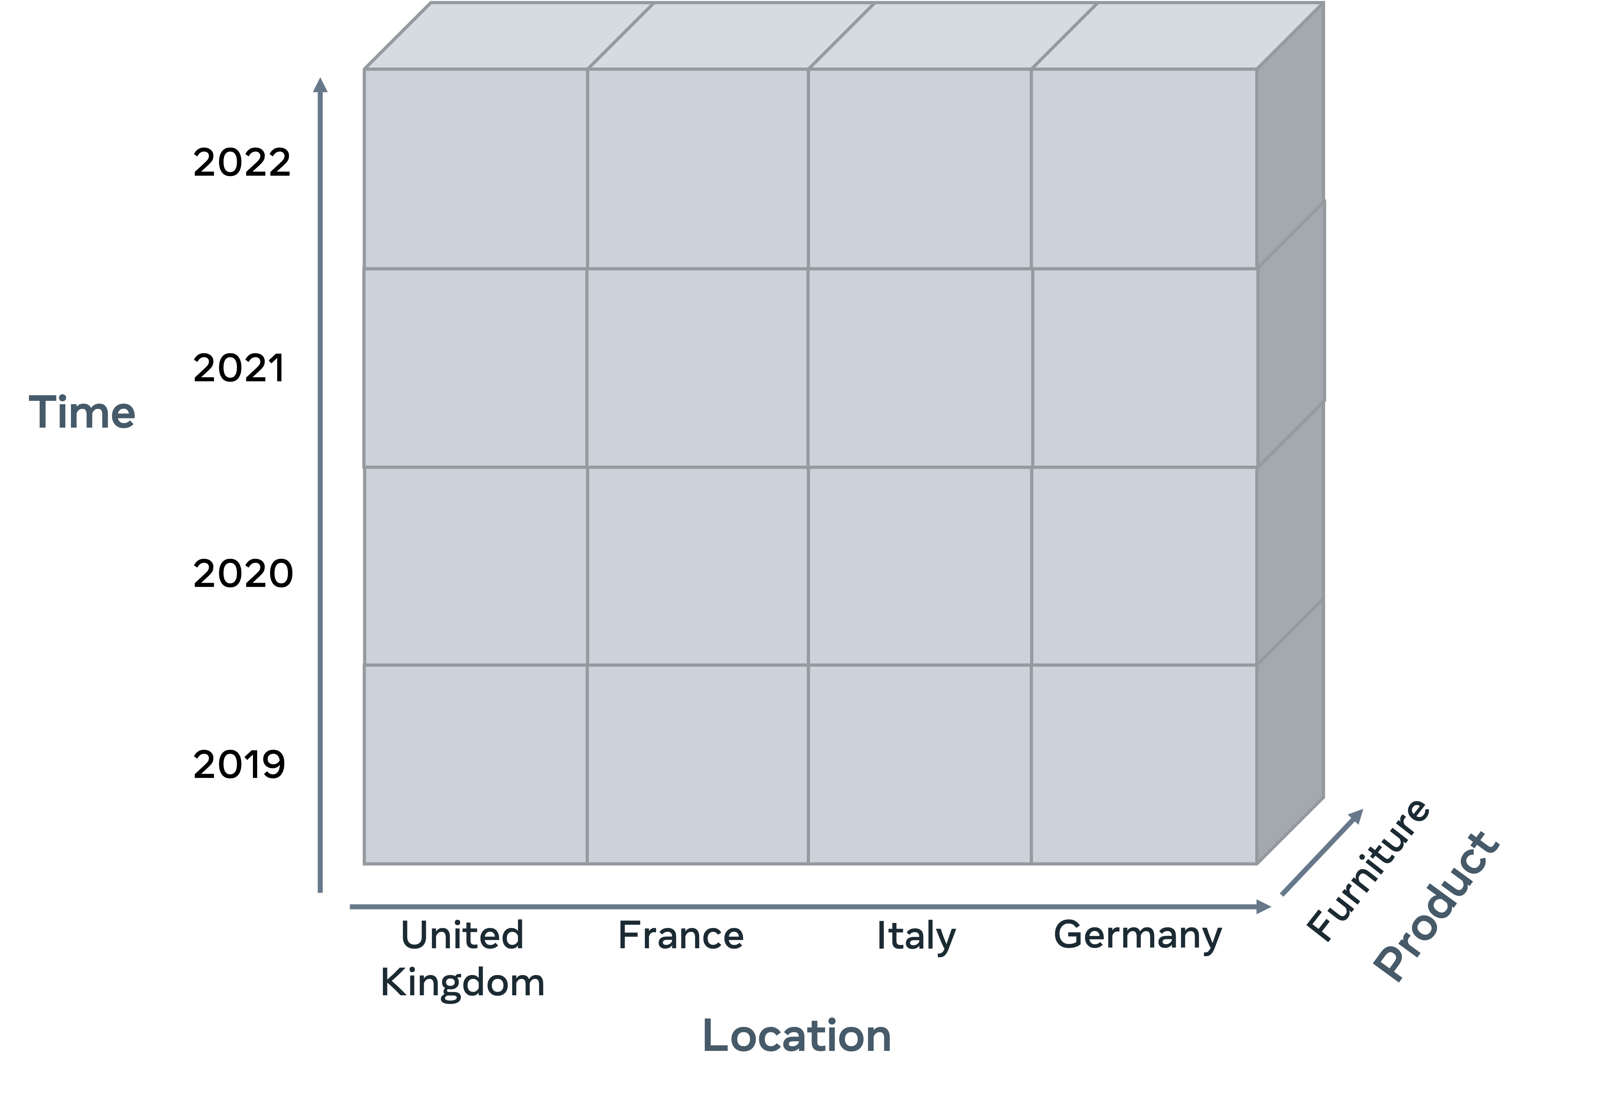

The chart below shows how the slice operation is used to address the question: “How have sales in the furniture category performed over the previous four years in each country?”

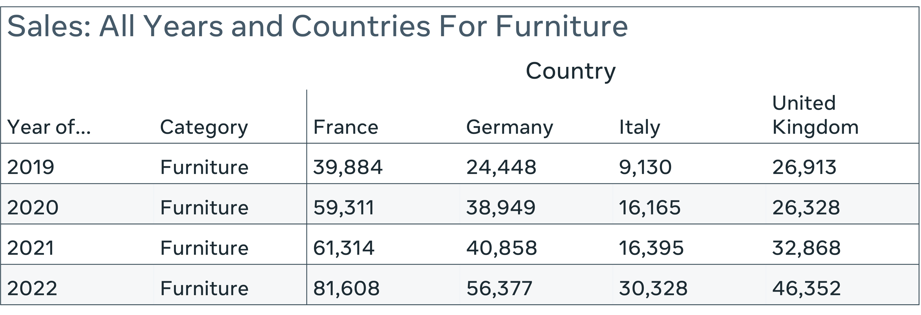

## **Pivot**

A Pivot operation provides an alternative view of data by rotating the axes of the cube. For example, the following cube rotates the Location and Time dimensions.

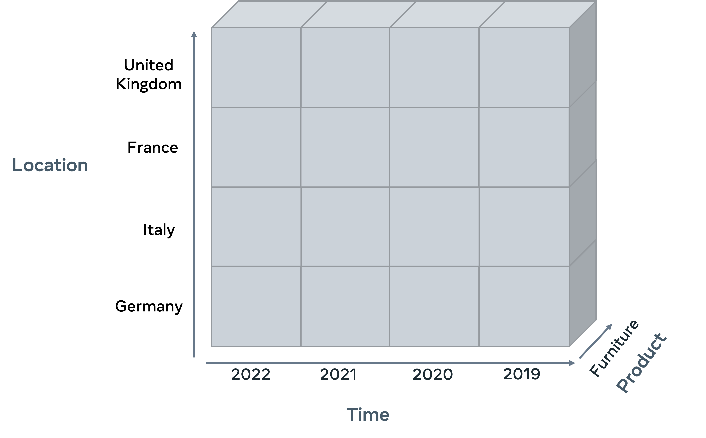Data in the previous chart (Slice) is now presented differently. Location and Time dimensions are swapped. Country data is now represented in the first column and the Years data is represented in the row, as shown below.

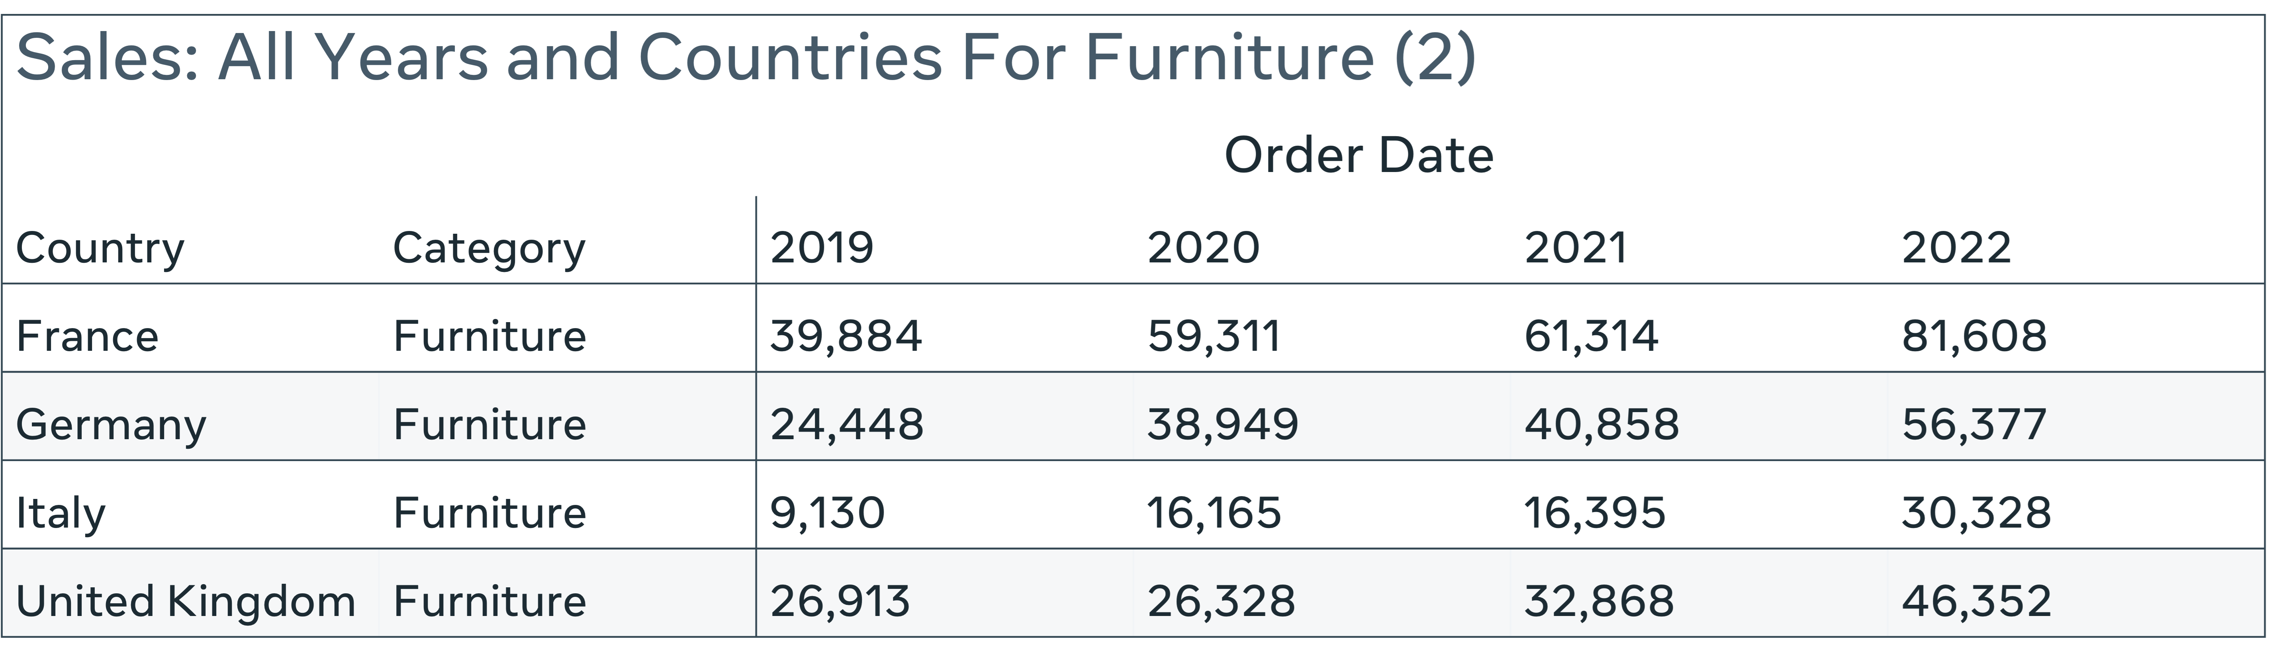

## **Dice**

The dice operation emphasizes two or more sub dimensions from the cube as shown below.

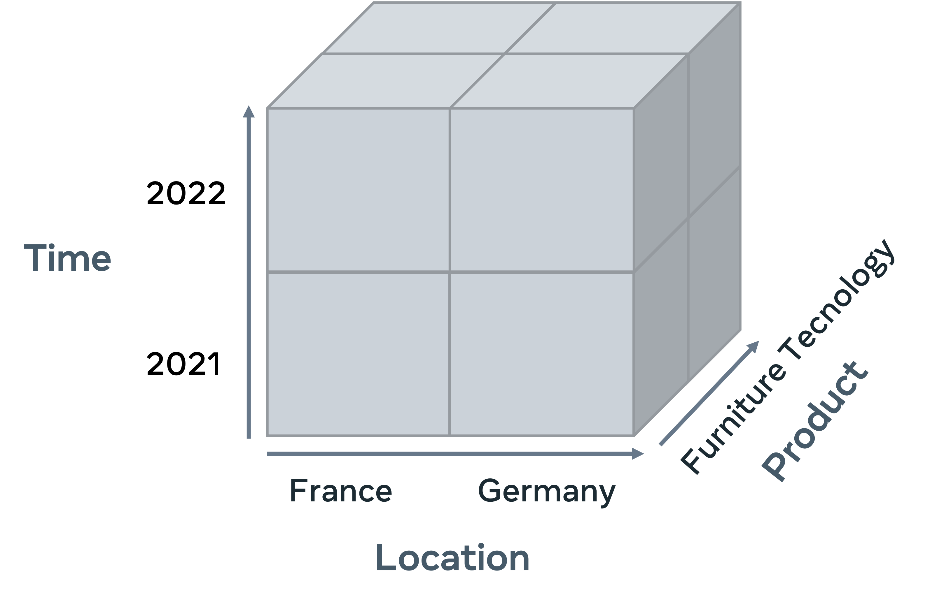

The following chart shows how the dice operation is used to address the question: “How have sales of furniture and technology products performed over the last two years in France and Germany?”

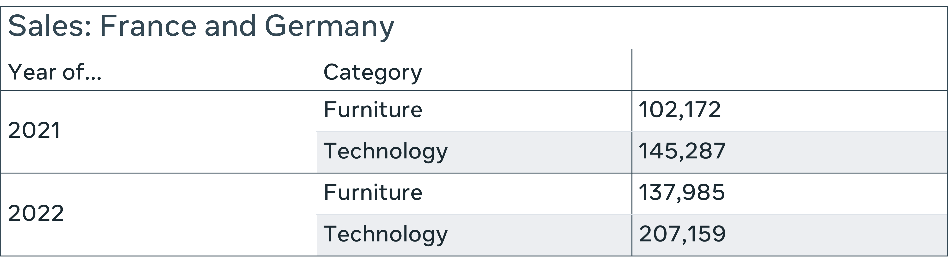

## **Drill-down and roll-up**

The multidimensional cube model also supports the hierarchical data structure. This allows you to drill down into a more specific area of data or roll-up to move into a higher level of data. The following chart, for example, uses the drill down operation to show data in quarters instead of years.

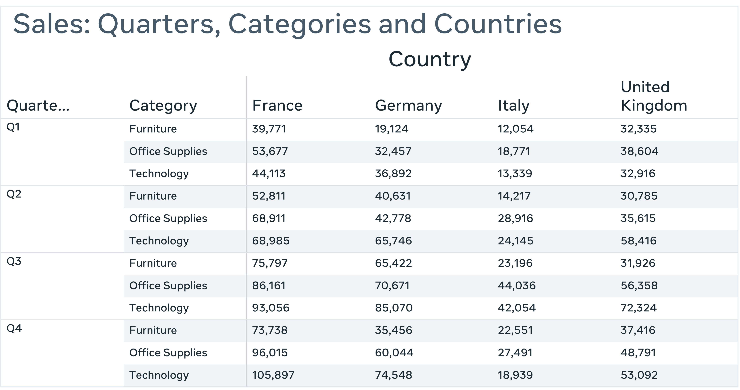

## **Conclusion**

OLAP cube is a multidimensional array of data used in Online analytical database systems to provide better insights. You can use the OLAP cube to perform different types of useful operations such as Drill-down, Roll-up, Slice, Dice and Pivot. These operations help you to analyze data from different perspectives. You should now be familiar with how the OLAP cube functions as a multi-dimensional array of data and how it is used in practice.

**Global Super Store’s dimensional data model**

Global Super Store are building a dimensional data model to analyze their data.

**Dimensional data model**→ A model which targets specific aspects of an organization to resolve key issues.

The model is created using a systematic approach that revolves around four key steps. These steps include the **business processes**, the **grain**, the **dimensions**, and the **facts**. Each of these steps is a choice. You need to choose a business process that your dimensional model must investigate. You then need to choose the facts and dimensions that can provide the answers you need.

When building a dimensional data model, the first step is to **identify or choose the specific business** process to be addressed. Once you've identified the process, you can then determine the **grain** of data in the data model. Global Super Store have decided that the business process to be addressed is their sales activity. Once you've decided on the process, you then need to choose the level of detail required. This **is referred to as the grain.** What granularity or level of detail is required for the data warehouse to address your process problem? And what's the lowest level of detail required to address the issue? For example, Global Super Store need to analyze their sales data at both a yearly and daily level. They also need to investigate this data at the global and local level. The next step in the process is to choose the dimensions. In this step, you need to choose the relevant dimensions. In other words, in what context do you need to explore your business activity? As you already know, Global Super Store need to analyze their sales data. And they need to analyze this data in the context of products, customers, time, and locations. So now that you've identified the business process, the grain, and the dimensions, it's time to establish the facts.

**The facts**

This is basically answering the question of, what do you want to measure?, Identify the measures attribute you need in the fact table. You need to select the measures that contain numeric data and populate your fact table with these attributes. For example, Global Super Store need to explore their facts using the dimensions tables, location, product, and time. They can demonstrate how each of these dimensions impacts the sales. And they can also include relevant attributes that provide useful information about each dimension. Once you've decided what aspect of your business process you need to investigate and chosen the grain, related facts and dimensions, you can then create your schema. Arrange your dimensions and dimensions tables. Global Super Store can arrange their dimensions and measures in a star schema. Their schema examines the performance of their sales activity in the context of four different dimensions, customers, products, locations, and time. And within each dimension is a set of relevant attributes that target the required data. Once you've decided what aspect of your business process you need to investigate and chosen the related data and dimensions, you can create your schema. Global Super Store have identified their dimensions and measures step by step based on their business requirements. They can now perform different forms of data analysis to achieve their goals.

# Additional resources

The following resources offer additional reading materials on the topic of dimensional data modeling:

* [Microsoft guide to star schemas and their importance to Power BI](https://learn.microsoft.com/en-us/power-bi/guidance/star-schema)
* [Oracle guide to data warehousing logical design](https://docs.oracle.com/en/database/oracle/oracle-database/21/dwhsg/data-warehouse-logical-design.html)
* [Integrate overview of snowflake and star schemas and their key differences](https://www.integrate.io/blog/snowflake-schemas-vs-star-schemas-what-are-they-and-how-are-they-different/)
* [Keboola guide to understanding OLAP cubes](https://www.keboola.com/blog/olap-cubes)

**------------------------->>>>>>>>>>WEEK3 <<<<<<<<←-----------------------------**

**Quantitative data →** data that can be counted or quantified. This is data that can be counted or quantified. In the case of Global Superstore, this includes the average number of customers who make purchases each day, or the average cost of each purchase made.

**Qualitative data →** textual and descriptive data. refers to non-numerical data. This is textual and descriptive data like information about the quality attributes of a product. For example, Global superstores qualitative data includes category names or descriptions of products like furniture or office supplies. Once you've determined what kind of data you're dealing with, you then need to organize, identify, and analyze your data. You can perform these actions using four different measurement scales. The first of these measurement scales is the nominal scale.

**Nominal scale →** describe the identity property of non-numerical data. This scale describes the property of non-numerical data. It's purely descriptive, which means it just identifies the data. In the case of Global Superstore, they can use this scale to identify products in their stock like a chair or a desk. Each product is one nominal unit of data. The next form of measurement is the ordinal scale.

**Ordinal scale →** places data in a specific ranked order. This is a qualitative data type scale which places data in a specific ranked order. However, it doesn't include decisive criteria to determine the difference between the data elements. For example, Global Superstore can rank chairs using ratings values, so they can use a value of one for top quality products, two for very good products, and three for good products and so on. However, there's no precise criteria that determines the measurement between each value.

**Interval scale →** identifies the difference between the data points. This scale includes properties of the nominal and order data scales. Its key feature is that the difference between data points can be clearly identified using specific criteria. The scale can also contain both positive and negative numbers, and zero does not represent an absolute true value. Global superstore can use the interval scale to provide feedback on products from 10 to -10.

**Ratio scale →** identifies and classifies data and marks intervals. This scale is a quantitative data type that includes properties from nominal, ordinal, and interval scales of measurement. It defines the identity of the data classifies the data in order and marks clear intervals.

**Data mining versus machine learning**

he terms data mining and machine learning are often used interchangeably. While they're both useful methods for analyzing data, they operate very differently.

**Data mining →** detecting patterns in data that have real-world benefits. You can then gain insights, make judgments, and deliver predictions based on these patterns.

**Machine learning →** teaching a machine to determine probabilities and make predictions. There are two main methods of machine learning, **supervised** and **unsupervised** machine learning. Supervised machine learning involves classifying data based on given labels. For example, Global Super Store can label the available chair and table images as CH and desks as DK. The computer can then learn to recognize, classify, and group these product images based on their labels. Unsupervised machine learning is when data is classified based on shared characteristics, but without the use of labels. The machine learns to recognize and categorize images of objects like chairs, tables, and desks based on the shape in the images. Machine learning makes use of many kinds of data mining models when processing data.

**classification analysis model** → This model assigns data items into categories or classes of data. You can then use this data to predict your target class for the items. For example, many Global Super Store customers purchase low-priced office products so they can be classified as low budget customers and targeted with advertisements for low budget products.

**Association rule model** → is a model that identifies the relationship between different data elements. It determines if there is a correlation between these elements based on certain criteria. Many Global Super Store customers who purchase cell phones also buy items like phone chargers and battery packs. This data suggests that these products should be advertised and sold together. The next model is outlier detection. Outlier detection is a model that reveals unusual data within a particular dataset. In other words, it detects data outliers are anomalies that don't conform to the expected pattern. For example, a group of Global Super Store customers with a shared history of purchasing low-priced products, suddenly begin purchasing expensive products. In this instance, the company needs to reclassify these customers and target them with advertisements for more expensive items.

**Clustering analysis model** → This model searches for similarities within a dataset. It then separate the data into clusters of subsets based on the similarities at fines or the common characteristics within the subsets. The model works in a similar manner to the classification analysis model. However, that model is initially assigned to predefine groups, not newly discovered ones. Global Super Store can use the model to classify low and high budget customers based on similar types of navigation behavior in the company's online store.

**regression analysis model** → This model considers the different factors that impact data. It then determines the relationship between these factors. This model can help Global Super Store to develop a better understanding of their sales patterns. The data shows that each time the store discount certain products, it leads to an increase in sales. The store can conclude that discounts impact sales data.

**The value of data insights in business**

## **Overview**

Organizations collect lots of data and store it in different kinds of databases. This data represents an important asset that can be used to examine business activities and performance. However, to gain the most benefit from this data, you need to treat it well so that it can be converted into a valuable resource.

Similarly, data can be accessed, extracted, refined and analyzed to find relationship between existing data to create insights that help the decision makers to plan their business activities, improve their services, reduce costs, minimize risks and increase revenues.

Data analytics does not stop at analyzing data to describe it (like how many customers placed orders, or the total sales values). This is just the first phase in data analytics. Data analytics processes data to evaluate future probabilities, identify problems, assess risks and predict future opportunities.

To carry out proper data analytics, you must perform different types of data analysis to identify models, patterns, paradigms and trends. This then helps you to gain an in-depth understanding of the business performance and to predict the future outcomes of  business activities. You might even get recommendations for best plans and courses of action.

## **Benefits of data analytics in business**

Over the past decade, data analytics has played a major role in determining how organizations assess risks and seek opportunities. Large corporations and organizations such as Amazon, Microsoft and Apple have invested billions of dollars in advanced data analytics.

It is important to realize that the ways in which data analytics can be utilized relies on many factors such as the requirements of the business, market conditions, competitors and the domain. Nevertheless, there are generic benefits that can be gained from data analytics regardless of the business size and type.

For example, data analytics can be used to:

* Provide refined, detailed and reliable insights that enhance day-to-day business decision making.
* Identify and exploit potential opportunities.
* Discover ways to monetize data.
* Identify threats such as security gaps and breaches.
* Predict and proactively respond to changes and challenges in the market.
* Obtain a panoramic view of the business activities and operations.
* Prevent fraud.
* And reveal new areas in which you can reduce business expenses or cost and increase profits.

It’s also important to remember that nowadays your business is part of the Big Data environment.  This is an environment which includes massive amounts of data, and many kinds of complex data, including structured, semi structured and unstructured data sets. This data comes from a wide variety of data sources such as OLTP databases, commercial data, browsing histories, search engines and social media sites.

For example, there are more than 500 terabytes of data generated every day by Facebook posts including images, comments and videos. Similarly, there are over 20 petabytes of data generated by Google processes every day across its massive computing clusters. These statistics highlight the importance of using artificial intelligence, machine learning and data mining to help businesses make data-informed decisions.

## **Data analytics techniques**

There are many techniques that can be used in data analytics to maximize the value of data insights. Some commonly used techniques with relevant examples are listed below.

### **Classification technique**

The classification technique assigns data items into categories or classes, which allows you to predict the target class of your data. For example, banks use this technique to identify loan applicants with low, medium, or high credit risks based on their historical credit ratings, employment history, property ownership and so on.

### **Association rule**

The association rule identifies the relationships between data elements to determine whether there is a correlation between data. A classic example of the association rule is identifying the relationship between two products in a store. For example, many customers who go to the store to buy a specific product might buy another related product. So, the data shows that there’s a relationship between these two products. This association might be based on data that shows 70% of the total number of the store’s transactions include both products. This data indicates that there is an association link between the two products.

### **Outlier detection**

Outlier detection is used to uncover unusual data within a data set. A common example in this analytics model is credit card fraud detection. This technique can be used to check whether the incoming transaction fits with the customer’s profile and behavior. If a request doesn’t fit a customer’s legacy profile and behavior, then it is flagged as an outlier or anomaly detection.

### **Clustering analysis**

Clustering analysis looks for similarities within a set of data. If it finds similarities, then it separates related data into clusters of subsets based on their common characteristics.

A good example of clustering analysis is online streaming services. These services use clustering analysis to identify and classify viewers engaged in similar types of streaming activity. The streaming services look at the amount of time a user spent watching videos, and the number of sessions they engaged in per day, week and month.

These metrics can be used within a cluster analysis to identify client habits. The services then know which demographics they should target with their advertisements and the best ways in which to reach them.

## **Conclusion**

In this reading, you learned about the role of data analytics, you discovered why it is a valuable skill and you saw how you can use different data analysis techniques to optimize business operations.

**Data visualization →** visualizing data so that decision makers can interpret it quickly and easily. Your role is to remove the noise from the data and present the important elements. Like trends, paradigms and outliers in a user friendly way. In other words, how can you tell an informative and engaging story through your data. There are four factors to consider when deciding what type of visual data to represent. The first of these is your target audience, who are you presenting this data to?, what's their background?. What's their level of understanding of the issues or topics to be investigated?, factor these questions into your presentation. You also need to carefully consider what information your visualization includes. What information answers your audiences questions, and what information is redundant. Another issue to consider is time, how much time do you want your audience to spend examining each chart? Should they be able to understand a chart after just a few minutes of observation or should it take them longer. And finally, think about the level of accuracy your audience is looking for. Does your audience just need to understand the data in a general sense or do they need to drill down into finer levels of detail. Once you've answered the key questions, identified your audience and determine what kind of data you need to show. It's time to decide on your data visualization charts, each type of chart has a different purpose. And each chart can be used to solve a different type of problem or communicate a different kind of message. What's most important is to select a chart that tells your audience the story of your data in the most appropriate way.

You need to present your data visualization charts to Global Super Store. factors must you consider when visualizing your data

1. Your audience’s understanding of data.

You need to present your data in a way that best suits your target audience and their understanding of the topic.

1. The time it takes to understand your charts.

Consider how long you need to spend on each chart to make sure that your audience understand the message you’re communicating.

1. The level of accuracy your data must communicate.

Consider just how much detail your audience require to understand your message.

1. The type of information your data must convey.

Your data must be focused on tackling a specific problem and exclude any redundant information.

**Bar chart →** draws comparisons between data values. It helps audiences to recognize differences or similarities between data values, you can present data horizontally or vertically, to show numerical comparisons across categories. Global Super Store uses a bar chart to depict the sale of products against profit ratio. This shows how much profit is made in each product category.

**Line graph →** shows connections between data points. a line graph shows quantitative data over a continuous interval or time period. Line graphs work by showing connections between data points on a Cartesian coordinate system. Over a Global Super Store they use line graphs to show the trend in profits over the last number of years.

**Bubble chart →** assigns a variable to bubbles to draw comparisons. a bubble chart shows the relationship between numeric variables. Each variable is assigned its own bubble, audiences can understand what a bubble chart is saying by comparing the sizes, positions and colors of the bubbles. For example, the larger bubbles and Global Super Stores bubble chart, indicate that the departments each bubble depicts are more profitable than the departments assigned to the smaller bubbles.

**Map chart →** presents data in geographical areas. Each data variable can be reflected in the map using a variety of different methods, like colors and labels. Global Super Store use map charts to visualize sales across different global regions.

**Scatter plot graph →** presents variables as point on a Cartesian coordinates grid .This graph plots variables as points on a Cartesian coordinates grid, you can then use these data points to search for correlations between variables. You can also add trending lines for each data group within category labels to show the performance of select categories. Global Super Store use this approach to depict sales and profits across different categories or departments.

# **Additional resources**

The following resources offer additional reading materials on the topic of advanced data analytics:

* [Aidata Analytics overview of how next level insights shape the future of business](https://www.aidataanalytics.network/business-analytics/articles/advanced-analytics-how-next-level-insights-are-shaping-the-future-of-business)
* [IBM guide to data mining](https://www.ibm.com/cloud/learn/data-mining)
* [Seldon guide to machine learning](https://www.seldon.io/supervised-vs-unsupervised-learning-explained)
* [Data visualization catalogue](https://datavizcatalogue.com/)

**Using advanced analytic tools for data analysis**

Data analytics is a complex process and the task is beyond the capabilities of traditional database management systems, that's why data analysis is performed using data analytics tools. These tools make it possible for users to view and understand large amounts of data using artificial intelligence.

**Data analytics →** tools help database users to generate insights and visualize data.

**Data analytics features**

→ useful for dealing with large databases.

→ They can deal with massive amounts of data.

→ They can work with data in many different formats

→ and they can interact with many different data sources and database systems.

In addition, each tool uses advanced data analysis techniques to generate insights and they provide advanced data visualization tools. These features make it much easier for users to view and understand their data. Tableau is a widely used data visualization tool.

**Tableau feature**

→ It stores data in the form of different data types like string, date and time.

→ It can connect to a wide range of data sources like MySQL, Microsoft SQL, MongoDB, BI and Oracle DB.

→ And it can interact with many different data sheets and file systems like Excel, Jason and PDF. In addition to these features, Tableau can also generate interactive dashboards that present data in real time, support multiple languages like scripting in Python and r programming languages and complete task using interactive UI tools like Drag and Drop.

# Getting started with Tableau

This reading provides an overview of Tableau and how you can start using it to build visual charts for data analytics.

## **Overview**

The Tableau platform is a leading analytics platform that supports efficient visual data analytics, data storytelling and interactive dashboards with live updates.

There are three versions of Tableau available for you to use including Tableau Prep Builder, Tableau Desktop and Tableau Cloud. However, for this course you must use the Desktop version.

You can download the desktop version on your machine from the following link:

* <https://www.tableau.com/products/desktop/download>

All the steps and technical requirements for installing Tableau on your machine are listed on the Tableau website in the following link:

* <https://www.tableau.com/products/techspecs>

There are also many free videos available on the Tableau website to help you get started:

* <https://www.tableau.com/learn/training/20212>

## **Getting Started with Tableau**

Tableau is used to analyze data and provide answers to different questions about business performance. However, before you can start analyzing data you need to connect Tableau to your data sources. Let’s take a few minutes to review Tableau and the process steps for creating visualizations of your data.

## **Opening Tableau and exploring the UI**

Launch Tableau to view the start page and the related options.

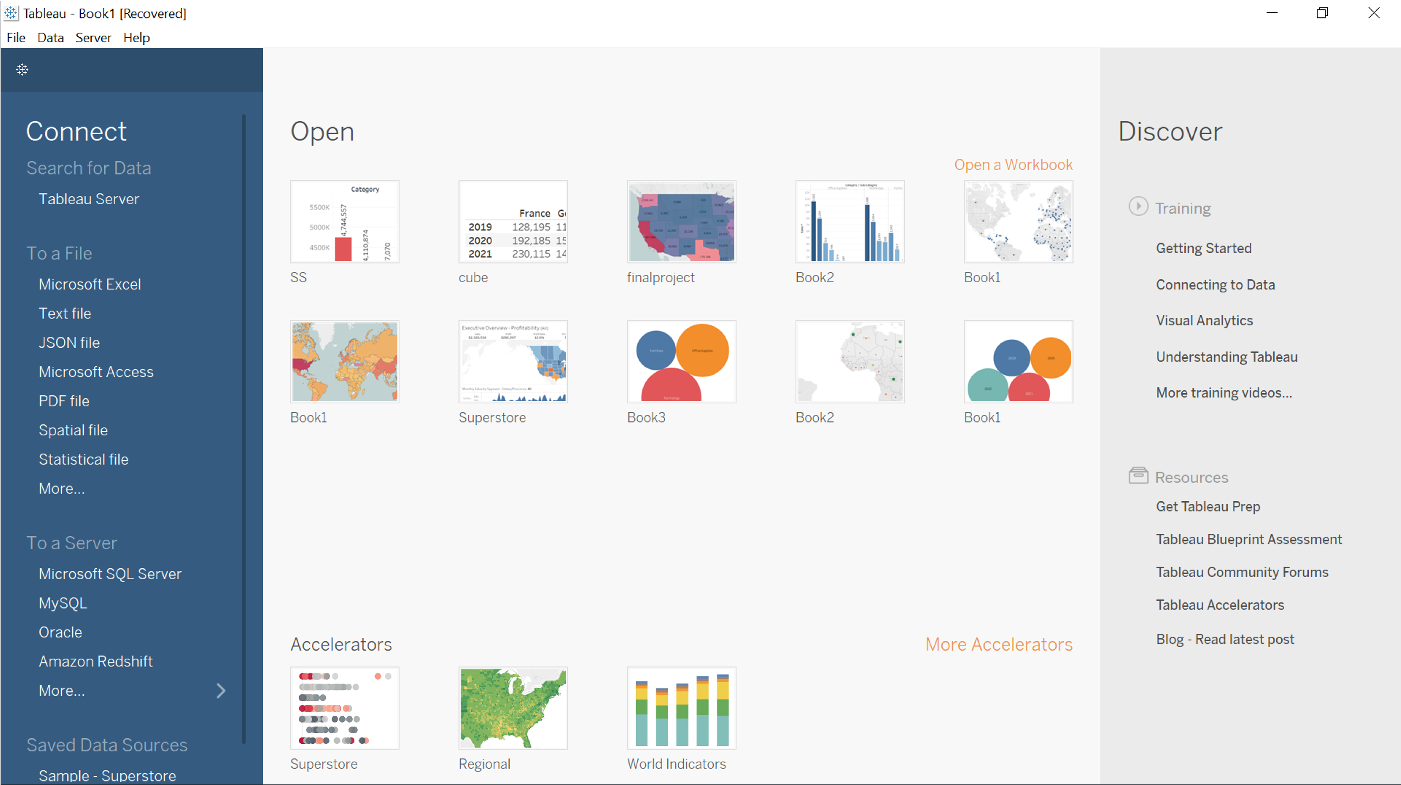

Here is an overview of the Tableau UI as shown above:

Open: Open workbooks. A Tableau workbook is a collection of different types of sheets such as worksheets, dashboards and stories.

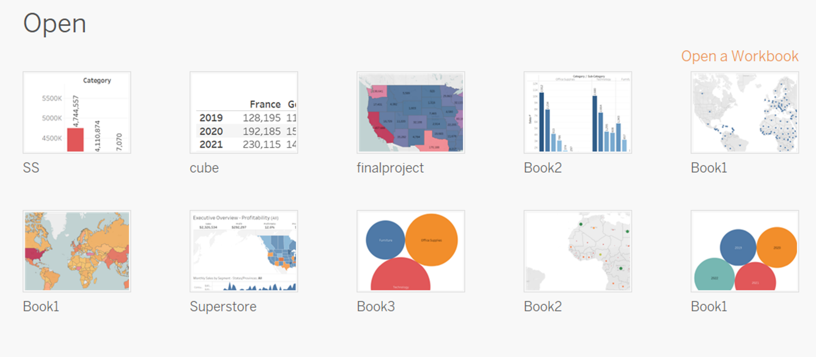

Accelerators: Provides sample workbooks.

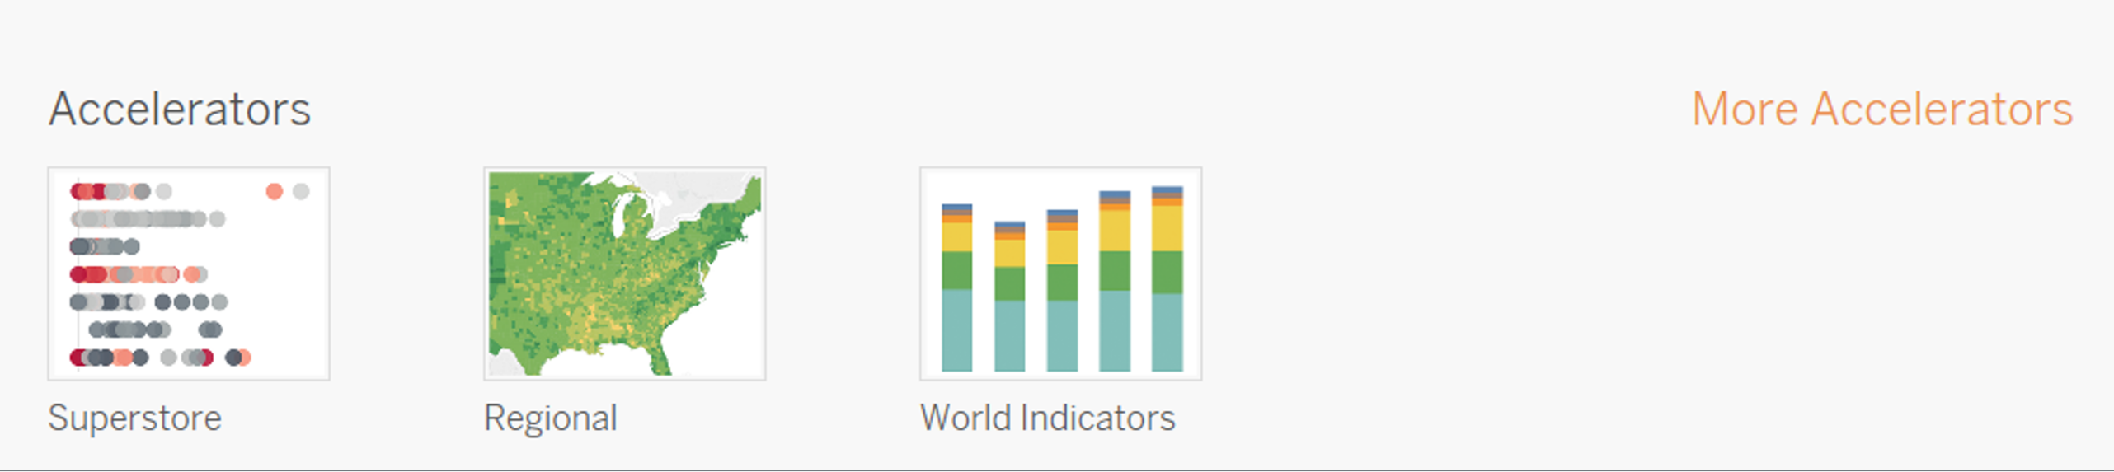

Discover: Offers access to useful learning resources like video tutorials, forums and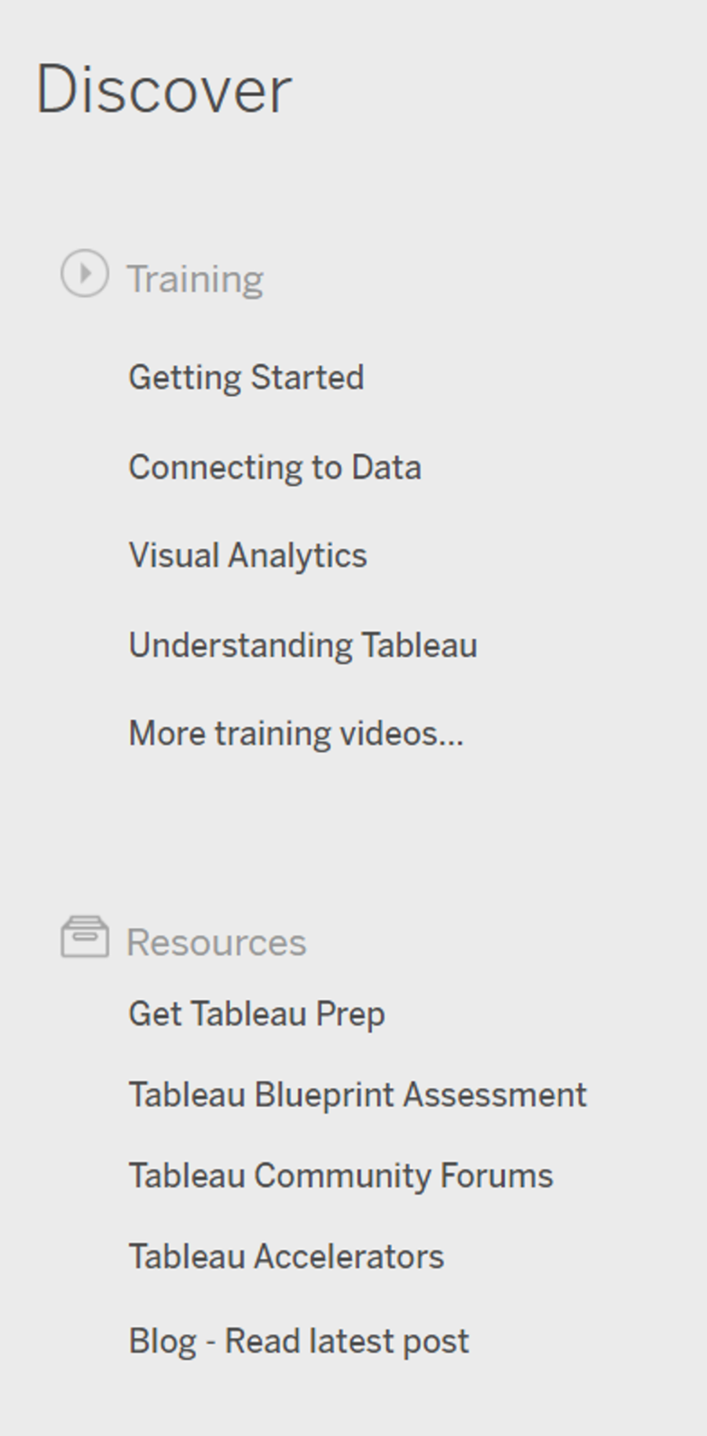 blogs.

Tableau logo icon: Used to switch between the start page and the authoring workspace.

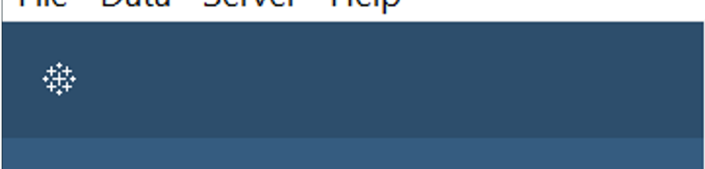W

Connect pane: Used to connect to data within different data sources. There are several types 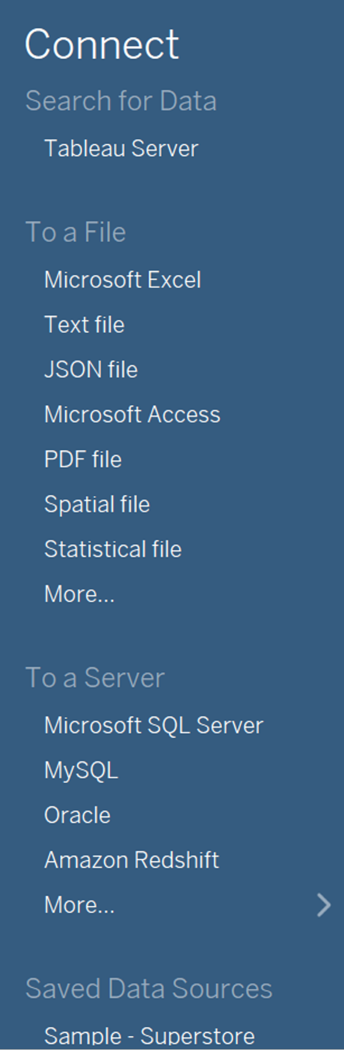of files and servers that you can connect to from the Connect section such as Microsoft Excel, Spatial files, MySQL and much more.

## **Visualizing your data**

As you’re aware, Tableau is used to visualize data. There are many ways in which you can visualize your data in Tableau including:

* Bar charts.
* Trend charts.
* And map charts.

Let’s review the steps for creating these different chart types.

## **Creating a bar chart**

To start analyzing the Global Super Store data, select Microsoft Excel. Navigate to the data source in your computer and select the Global Super Store file.

This action loads the file data into the Tableau Data pane, which contains information about all orders placed with Global Super Store including products, sales, customers and shipping data.

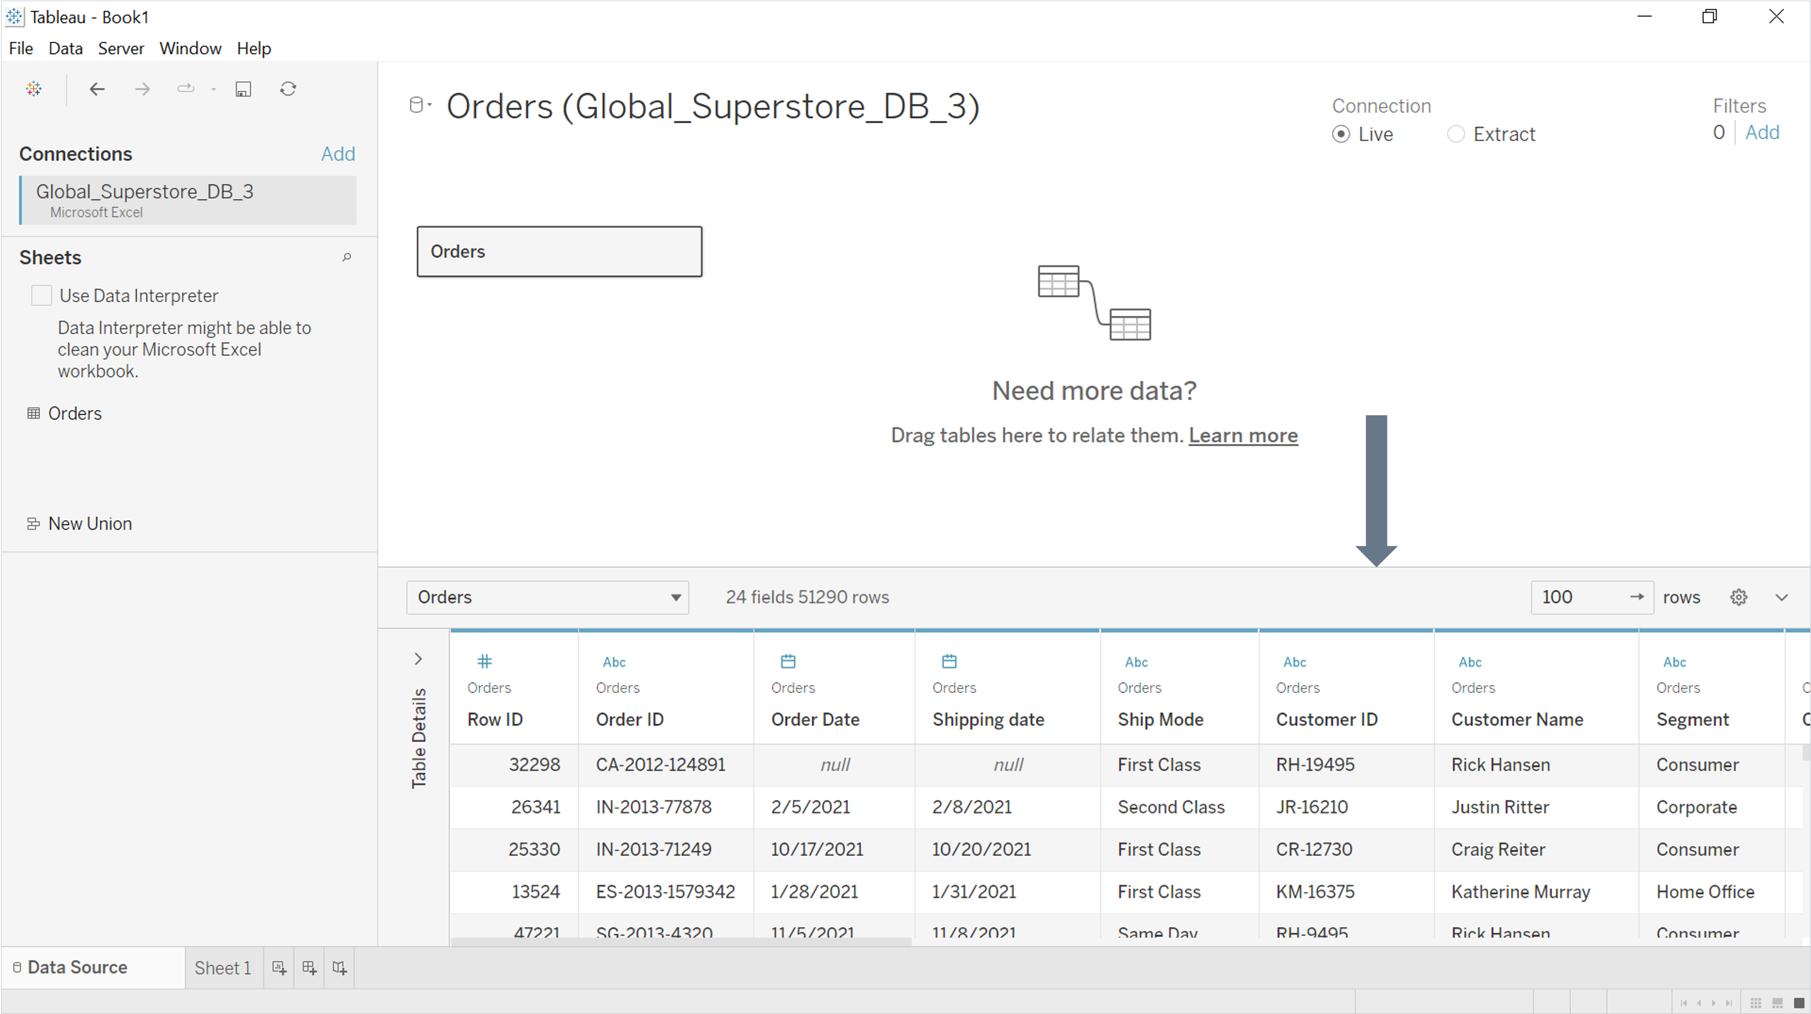W

Now you need to create a bar chart that shows overall sales across all categories of products. You can then explore your results and determine how to improve sales. Select the worksheet tab to begin performing data analysis and create a visualization of Global Super Store’s data.

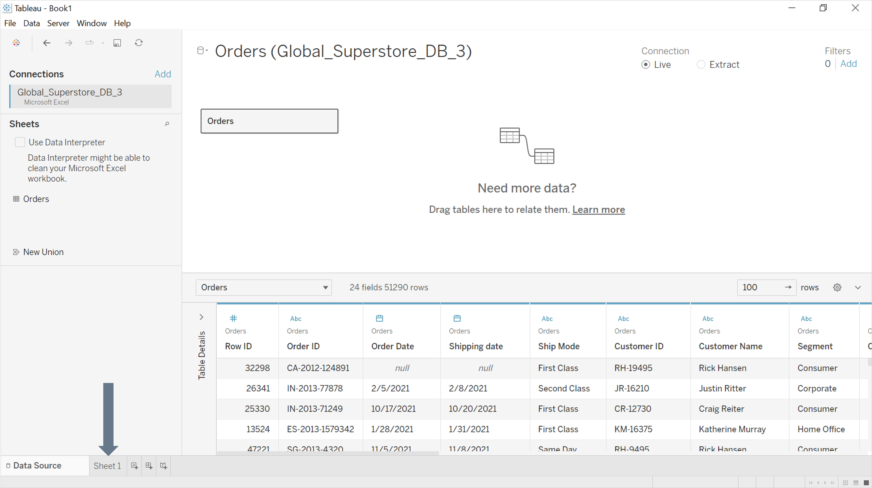W

This action redirects you to the worksheet authoring space.

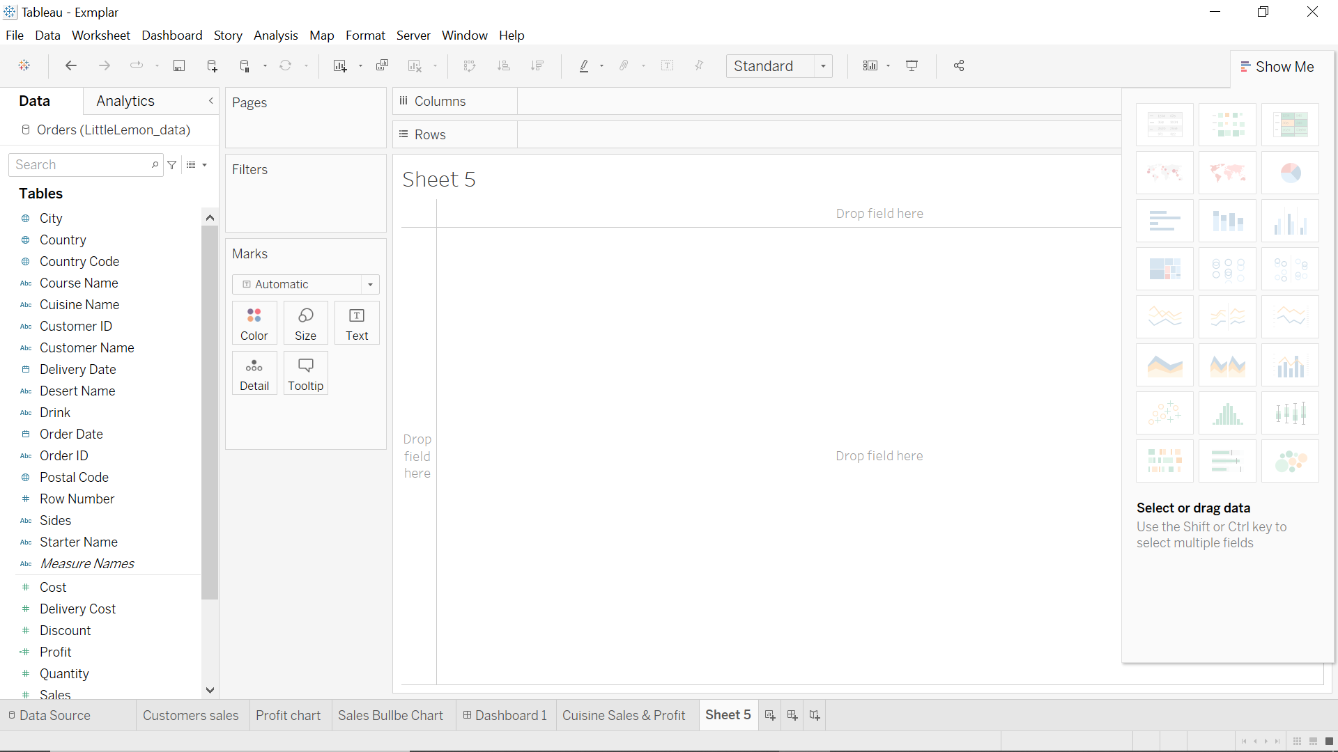W

Within this authoring space, you can drag and drop relevant dimensions and measures fields directly into the canvas area.

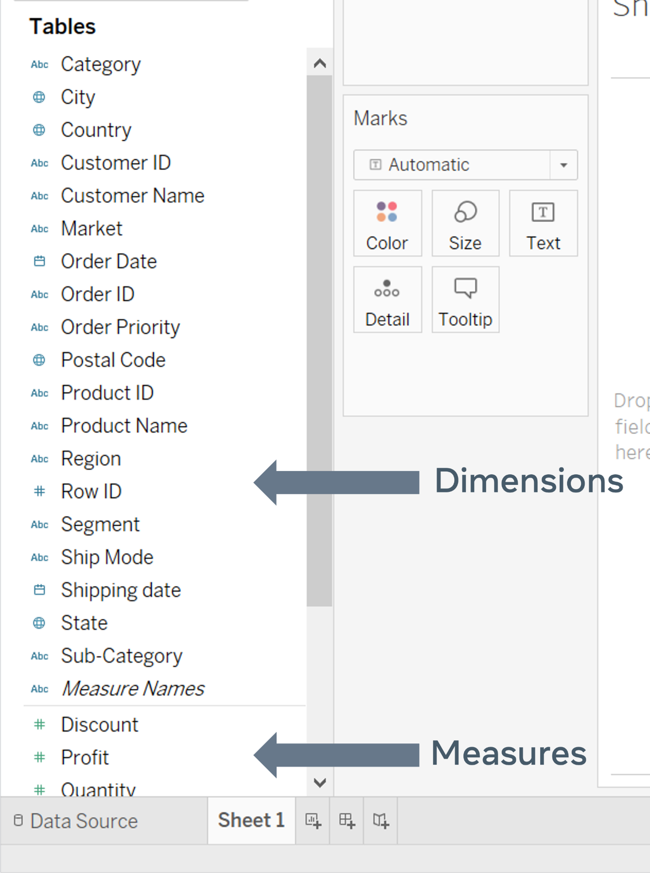W

You can move data to the cards area, or to the column and row in the shelves section.

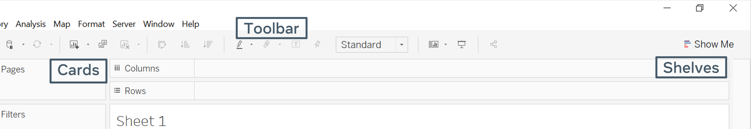W

To complete your task, drag the category option into the column shelf and the sales option into the row shelf. This creates a bar chart with relevant information.

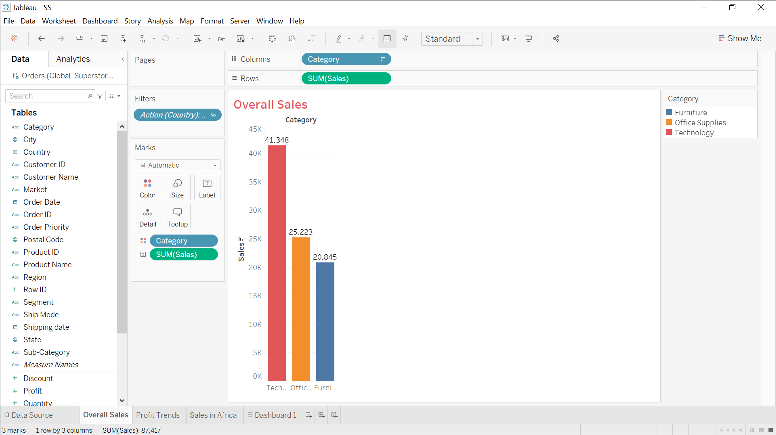W

You can also make some changes to the chart’s appearance to make it more visually engaging:

* Organize the bars in ascending or descending order using the related icons in the toolbar.
* Drag the category field from the Data pane into the Color box of the Marks card.
* Drag the sales field from the Data pane into the Label box of the Marks card.
* Provide the worksheet with a meaningful name.

## **Create a trend chart**

You have now created a bar chart that shows sales for all categories. Next, you need to build a new view in which you can review profits trends by category over the past several years. A trend chart is best suited to this task. Carry out the following steps to complete this task:

* Drag the Order Date field from the Data pane into the column shelf.
* Drag the Profit field from the Data pane into the row shelf.
* Drag the category field from the Data pane into the Color box of the Marks card.
* Drag the category field from the Data pane into the Label box of the Marks card.
* Provide the worksheet with a meaningful name.

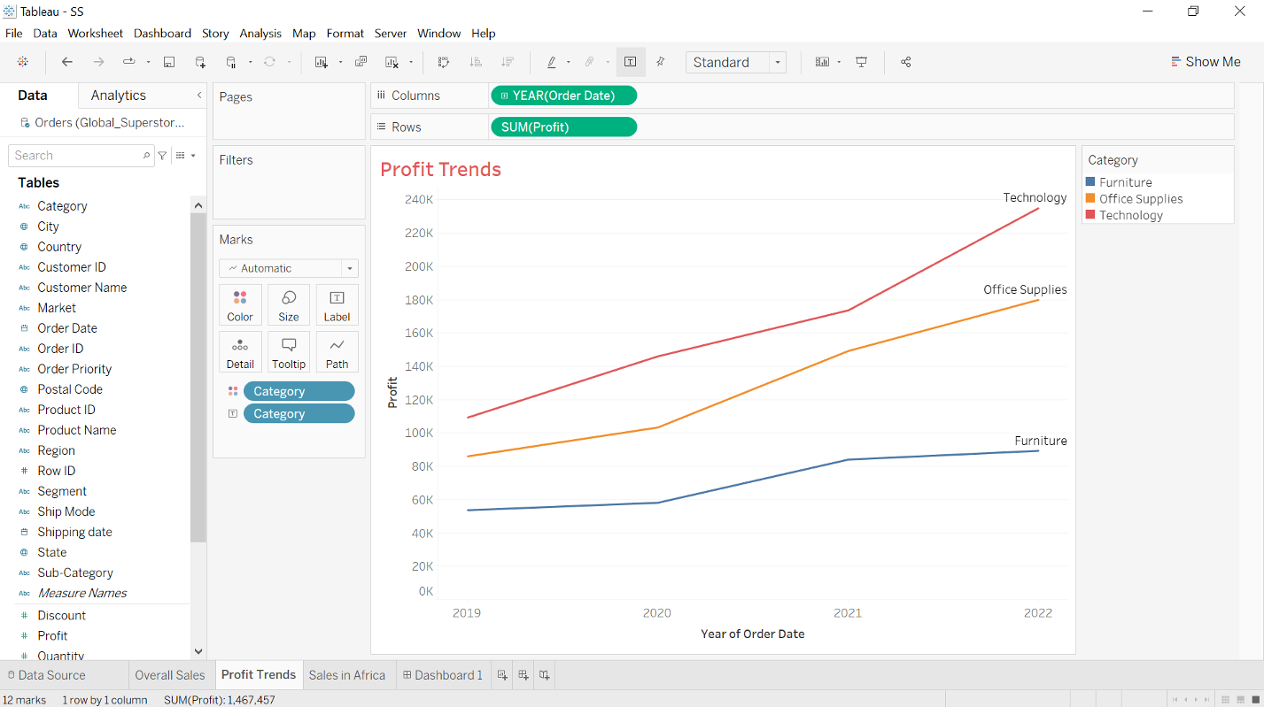W

## **Creating a map chart**

Your next task is to explore Global Super Store’s sales and profits in Africa and determine in which countries the company is performing best. You can use a map chart to complete this task. Carry out the following steps to complete this task:

* Double click the Country field in the Data pane, to create a map in the canvas area.
* Drag the Region field from the Data pane into the row Filter card then select Africa.
* Drag the Country field from the Data pane into the Color box in the Marks card.
* Drag the Sales field from the Data pane into the Size box in the Marks card.
* Drag the Profit field from the Data pane into the Tooltip box in the Marks card.
* Provide the worksheet with a meaningful name.

You now have several different types of charts that you can use to identify sales trends and paradigms. Global Super Store can use these charts to compare their sales data and make business decisions.

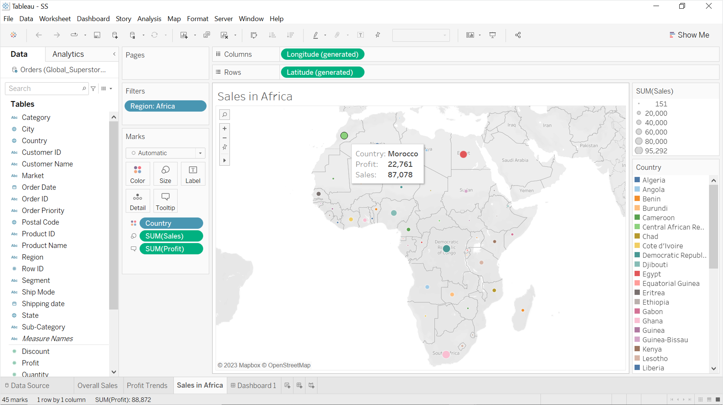W

## **Conclusion**

The Tableau platform provides you with advanced data analytics tools that support efficient visual data analytics, data storytelling and interactive dashboards. Having completed this reading, you should now be familiar with the Tableau workspace and the process steps for creating visual charts for data analysis. In the rest of this lesson, you’ll learn more about data preparation and the development of interactive dashboards.

Dimension fields hold Categorical qualitative data

# **Additional resources**

The following resources are additional reading materials about data analytics with Tableau.

* [Download link for Tableau Desktop](https://www.tableau.com/products/desktop/download)
* [Tableau training videos](https://www.tableau.com/learn/training/20212)
* [Tableau data literacy for all](https://www.tableau.com/learn/data-literacy)
* [Guide to the Tableau workspace environment](https://help.tableau.com/current/pro/desktop/en-us/environment_workspace.htm)
* [Guide to filtering data from data sources in Tableau](https://help.tableau.com/current/pro/desktop/en-us/filtering_datasource.htm)